Spruce Lake Elderhostel OBSERVING THE NIGHT SKY Robert C. Newman
June 1-6, 1997 Biblical Seminary
1. EARTH AND SKY

Climate at Philadelphia, lat 39º56'58"N; long 75º09'21"W
Normal monthly temperature: 30-yr averages

month 1961-90 1951-80

January 30 31
February 33 33
March 42 42
April 52 53
May 63 63
June 72 72
July 77 77
August 76 75
September 68 68
October 56 57
November 46 46
December 36 36
(From 1997 World Almanac)

Sunrise/Sunset at Phila (40N, 75W)
Note: maxima and minima (bold) show earth's orbit not circular

date sunrise sunset

Jan 1 7:22 16:46
Jan 15 7:20 16:59
Feb 1 7:09 17:19
Feb 14 6:54 17:35
Mar 1 6:34 17:52
Mar 15 6:12 18:07
Apr 1 5:44 18:24
Apr 15 5:22 18:38
May 1 5:00 18:55
May 15 4:45 19:08
Jun 1 4:33 19:23
Jun 15 4:31 19:30
Jul 1 4:35 19:33
Jul 15 4:44 19:28
Aug 1 4:58 19:14
Aug 15 5:11 18:57
Sep 1 5:28 18:32
Why is the sky blue in the daytime and black at night?

Why is the sun red when it rises and sets?

Sep 15 5:41 18:09
Oct 1 5:56 17:42
Oct 15 6:10 17:21
Nov 1 6:29 16:58
Nov 15 6:46 16:43
Dec 1 7:03 16:35
Dec 15 7:15 16:36
(From 1997 World Almanac)
Horizon

On an ideal smooth, spherical earth, our horizon is where a flat, broad cone with apex at our eye height tangentially touches the surface of the earth.
Can you see farther in the daytime or at night?

How far can you see?

The extremes:
At eye height approaching infinity, cone becomes a cylinder, so we can see one full half of the earth; with earth's circumference c25 K mi, this means horizon is about 1/4 this distance, 6250 mi.
At eye height approaching zero, cone becomes a flat plane, can see virtually none of earth, so horizon is basically zero.

On the real earth, neither smooth not exactly spherical, horizon distance will vary in different directions due to details of relief and various obstacles (vegetation, buildings, etc.). If viewpoint is above local roughness, result is simpler, but will still depend on roughness near horizon in each direction.

Ideal calculation:
Let h = local ht of observer, R = radius of earth, D = distance to horizon; then since tangent point is a right angle, by Pythagoras' theorem:

(h + R)² = R² + D²

h² + 2hR + R² = R² + D²

h² + 2hR = D²

D = SQRT (h² + 2 hR)

Example:
Let h = 5 ft, i.e., observer standing on surface.
R = 4000 mi; h = .001 mi
for h << R, equation simplifies to D = SQRT (2hR)
D = SQRT (2x.001x4000) = SQRT (8) = 2.74 mi
Table: Ideal Horizon for Various Heights

R (earth) = 3963.2 mi; h (in miles)
D = SQRT (7926.4h) = 89 SQRT(h)

ht of observer (h) horizon dist (D)

5 ft 2.7 mi
10 ft 3.9 mi
100 ft 12.3 mi
1000 ft 38.7 mi
1 mi 89 mi
10 mi 126 mi
100 mi 890 mi

Earth's Rotation

Earth rotates on its axis once in 24 hours. A complete rotation is 360º, so rotation rate is 360º/24 hr = 15º/hr, which is 15º/hr/60 min/hr = 1/4 deg/min or 4 min/deg.

Since the apparent diameter of both the sun and moon as viewed from the earth is about 1/2 degree, the sun and moon appear to move across the sky at about about one diameter every two minutes.

If the sun or moon sets vertically compared to the horizon, then (ignoring effects of refraction by the atmosphere), the time of setting from when the lower edge first touches the horizon until the upper edge disappears would be about 2 minutes.

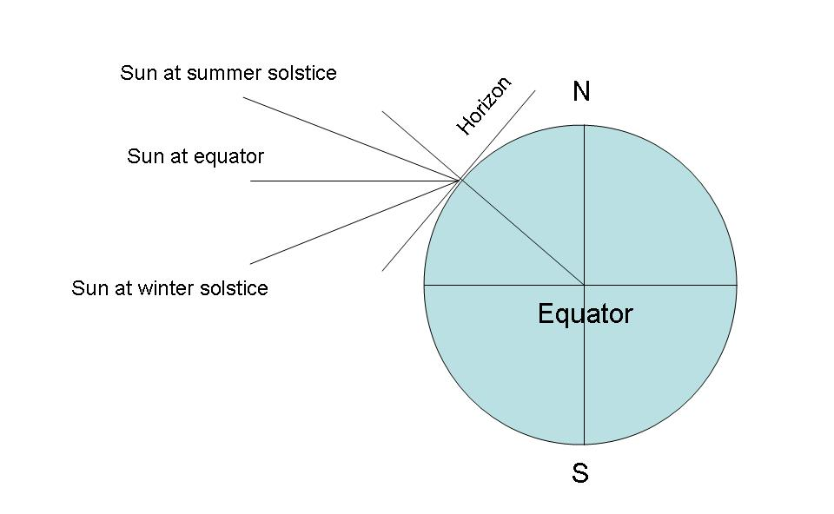
But the sun, etc. does not set vertically as far north as we are. Have to calculate the tilt of our horizon and such. If we take the horizon tilt to be zero at the equator and 90º at the north pole, then our tilt at a given latitude will be equal to that of the latitude, so at Phila, tilt = 40 deg. This is fixed relative to the equator, as long as the earth does not shift its pole of rotation, or No Amer continent move too far.

The sunset angle, however, varies with the season, since the earth's axis faces toward the sun in summer and away in winter. The angle of the earth's axis is about 23º27' or 232 deg. At the spring and fall equinoxes, the direction to the sun and the equator are aligned, so the sunset angle (measured from the vertical) will be the same, or measured from the horizontal, SS = 90 - lat.
For Phila, this will be SS = 50º. The two extremes are the winter solstice and the summer solstice, which are 232º smaller and larger than this.

Philadelphia, 40 deg N lat
Date Angle sun makes w/ horizon at rising/setting

Mar 21 50º
Jun 21 732º
Sep 21 50º
Dec 21 262º

Measuring Angles

Since the distance to the sky is indeterminate, distances on the celestial sphere are measured as angles rather than miles (or whatever). Standing on the surface of the earth, with no high hills or such around, it is about 90º from the horizon to the zenith, or 180º from one horizon to the horizon opposite.

For smaller angles, it is convenient (if not terribly accurate) to use your anatomy for making measurements. Say the distance from your eye to your stretched out thumb is about 24" or two feet. And that your spread-out hand (span) is 9" from thumb to tip of small finger, that your palm width (without counting thumb) is 3" and your thumb width is 3/4".

Then, since the angle marked out by an object of length L at length L away is about 70º, then
Rules of Thumb

Span 26º
Palm 9º
Thumb 2º

So your outstretched thumb marks off about 4 times the width of the sun or moon, about the distance (at the equator) that the celestial sphere turns in 8 minutes. You palm marks off the distance it turns in about half an hour (actually 36 min). Two spans mark off a 45º angle. The sun or moon is about the size of the cross section of a pencil at arm's length.
2. MOON AND PLANETS

Our Moon:

Moon:
Radius = 1738 km = 1080 mi
Mass = 7.32 x 10²⁵ g = 7 x 10¹⁹ mT = 80 quintillion tons
Orbit = Distance from earth = 385,000 km = 239,000 mi

The Planets:

Earth:
Radius = 6378 km = 3963 mi  4000 mi
Mass = 5.997 x 10²⁷ g  6 x 10²¹ mT = 6.6 sextillion tons
Gravity = 9.8 m/sec² = 32 ft/sec²
Orbit = 1 AU = 149.6 million km  93 million mi

Planet | a  (AU) | Orbit. Period | Rot.  Period | Mass* | Radius* | Density+ | Surface  Gravity* | Known  Moons
Mercury | 0.39 | 88d | 58.7d | .055 | .382 | 5.4 | .377 | 0
Venus | 0.72 | 225d | 243d | .815 | .949 | 5.3 | .905 | 0
Earth | 1.00 | 365d | 23.9h | 1.00 | 1.00 | 5.5 | 1.00 | 1
Mars | 1.52 | 1.88y | 24.6h | .107 | .533 | 3.9 | .377 | 2
Juptier | 5.20 | 11.9y | 9.92h | 318 | 11.2 | 1.3 | 2.54 | 16+
Saturn | 9.54 | 29.5y | 10.7h | 95.2 | 9.45 | 0.7 | 1.07 | 19+
Uranus | 19.2 | 84y | 17.3h | 14.5 | 4.10 | 1.2 | .869 | 15
Neptune | 30.1 | 165y | 16.1h | 17.0 | 3.90 | 1.7 | 1.14 | 8
Pluto | 39.4 | 248y | 6.4d | .003 | .18 | 2.0 | .07 | 1

*cp earth's +cp density of water
Source: David Morrison, The Planetary System (Astronomical Society of the Pacific, 1989)
Other Moons (Satellites):

Planet | Moon | a (km) | period (days) | mass* | radius (km)
Earth | Moon | 385,000 | 27.3 | 1.00 | 1738
Mars | Phobos | 9,380 | 0.319 | 1.3 [-7] | 12i
 | Deimos | 23,500 | 1.26 | 2.7 [-8] | 7.5i
Jupiter | Io | 422,000 | 1.77 | 1.2 | 1816
 | Europa | 671,000 | 3.55 | 0.66 | 1569
 | Ganymede | 1,070,000 | 7.16 | 2.0 | 2631
 | Callisto | 1,883,000 | 16.7 | 1.5 | 2400
Saturn | Mimas | 186,000 | 0.942 | .0005 | 197
 | Enceladus | 238,000 | 1.37 | .001 | 251
 | Tethys | 295,000 | 1.89 | .01 | 524
 | Dione | 377,000 | 2.74 | .014 | 560
 | Rhea | 527,000 | 4.52 | .034 | 765
 | Titan | 1,220,000 | 16.0 | 1.8 | 2575
 | Hyperion | 1,481,000 | 21.3 | ? | 135i
 | Iapetus | 3,561,000 | 79.3 | .026 | 718
 | Phoebe | 12,950,000 | 550r | ? | 110
Uranus | Miranda | 130,000 | 1.41 | .001 | 243
 | Ariel | 191,000 | 2.52 | .02 | 580
 | Umbriel | 266,000 | 4.14 | .02 | 600
 | Titania | 436,000 | 8.71 | .05 | 805
 | Oberon | 583,000 | 13.5 | .04 | 775
Neptune | Triton | 354,600 | 5.88r | 0.8 | 1430
 | Nereid | 5,510,700 | 359 | 2 [-8] | 470
Pluto | Charon | 19,700 | 6.39 | .02 | 600

*cp our moon's [-n] means times -n powers of 10 r = retrograde i = irregular
Source: Morrison, Planetary System

3. SUN AND STARS

A star is a huge ball of gas held together by its own gravity. Our sun is a star, by far the nearest one to us.

Because gravity is a spherically symmetric force, a star is spherical, except for a larger or smaller bulge at its equator, depending on how fast it is spinning.

The force of gravity heats up the gas inside the star, until it reaches a temperature high enough to turn on a nuclear reaction by which hydrogen is converted to helium. Thereafter the star produces light and heat from the energy produced by this reaction until the hydrogen in its core is exhausted. Stars getting their energy from hydrogen are called Main Sequence stars.

Principal Stellar Classes of Stars
Type | Class | Surface Temp (deg K) | Example
Hottest, bluest | O | 40,000 | Alnitak (zeta Orionis)
Bluish | B | 18,000 | Spica (alpha Virginis)
Bluish-white | A | 10,000 | Sirius (alpha Can Maj)
White | F | 7,000 | Procyon (alpha Can Min)
Yellowish-white | G | 5,500 | Sun
Orangish | K | 4,000 | Arcturus (alpha Bootes)
Coolest, reddest | M | 3,000 | Antares (alpha Scorpii)

Source: Wm K Hartmann, Astronomy: the Cosmic Journey (Wadsworth, 1989)

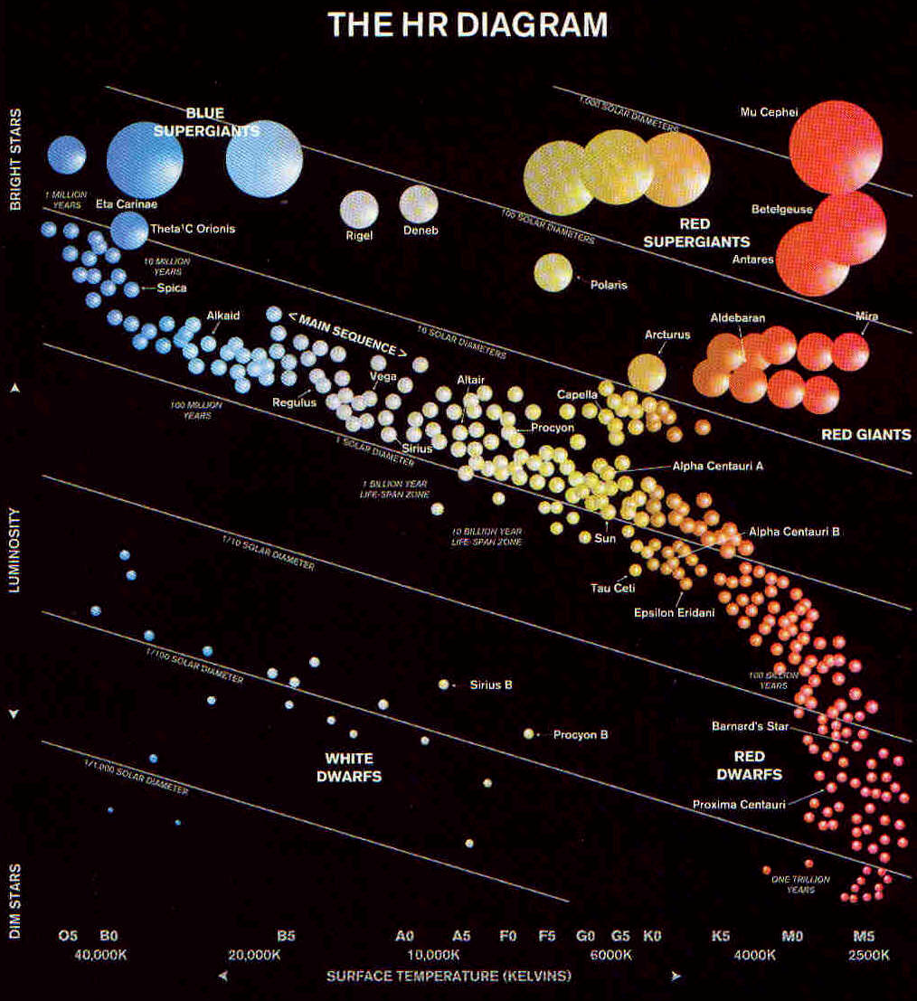

The (17) Brightest Stars as Seen from Earth
Star Name  (Constellation) | Apparent  Magnitude | Luminosity  (cp sun) | Type | Radius  (cp sun) | Distance  (light yr)
Sun | -26.7 | 1.0 | Main seq | 1.0 | 0.0
Sirius (Can Maj) | -1.4 | 23 | Main seq | 1.8 | 8.8
Canopus (Carina) | -0.7 | (1400) | Supergiant | 30 | 110
Arcturus (Bootes) | -0.1 | 115 | Red giant | (25) | 36
Rigel Kent (Centaurus) | 0.0 | 1.5 | Main seq | 1.1 | 4.3
Vega (Lyra) | 0.0 | (58) | Main seq | (3) | 27
Capella (Auriga) | 0.1 | (90) | Red giant | 13 | 46
Rigel (Orion) | 0.1 | (60,000) | Supergiant | (40) | (910)
Procyon (Can Min) | 0.4 | 6 | Main seq | 2.2 | 11
Archernar (Eridanus) | 0.5 | (650) | Main seq | (7) | 120
Hadar (Centaurus) | 0.7 | (10,000) | Supergiant | (10) | 490
Betelgeuse (Orion) | 0.7 | 10,000 | Supergiant | 800 | 520
Altair (Aquila) | 0.8 | (9) | Main seq | 1.5 | 16
Aldebaran (Taurus) | 0.9 | 125 | Red giant | (40) | 68
Acrux (So Cross) | 0.9 | (2500) | Main seq | (3) | (360)
Antares (Scorpius) | 0.9 | (9000) | Supergiant | (600) | (520)
Spica (Virgo) | 1.0 | (2300) | Main seq | 8 | 274
Source: Hartmann, Astronomy; numbers in parentheses are estimates.

Some Prominent Star Clusters
 | Name | Distance (ly) | Diameter (ly) | Mass (sun = 1) | Age (yr)
Open Clusters | Ursa Major | 68 | 23 | 300 | 200M
 | Hyades | 137 | 16 | 300 | 500M
 | Pleiades | 415 | 13 | 350 | 100M
 | Beehive (M44) | 518 | 13 | 300 | 400M
Globular Clusters | M4 | 6500 | 30 | 150,000 | 1.4B
 | M13 | 21500 | 35 | 660,000 | 1.4B
 | M5 | 25000 | 40 | 850,000 | 1.4B
 | M3 | 32500 | 42 | 1,100,000 | 1.4B

Source: Hartmann, Astronomy
4. THE GALAXIES

A galaxy is a much larger collection of stars than an open or even a globular cluster, which are parts of galaxies. Galaxies were once called nebulae, then later, "island universes."

Our galaxy has been called "the Milky Way" since ancient times, long before we knew what it was. It is shaped rather like two fried eggs laid back-to-back, or a pair of marching-band cymbals, that is, a rather flat disk of stars with a flattened-roundish bulge of stars in the center. It appears to be about 100,000 ly across the disk, which is perhaps only 10,000 ly thick. The bulge is perhaps 30,000 ly thick by 40,000 wide. The disk has very prominent spiral arms characterized by dust clouds and young, bright stars.
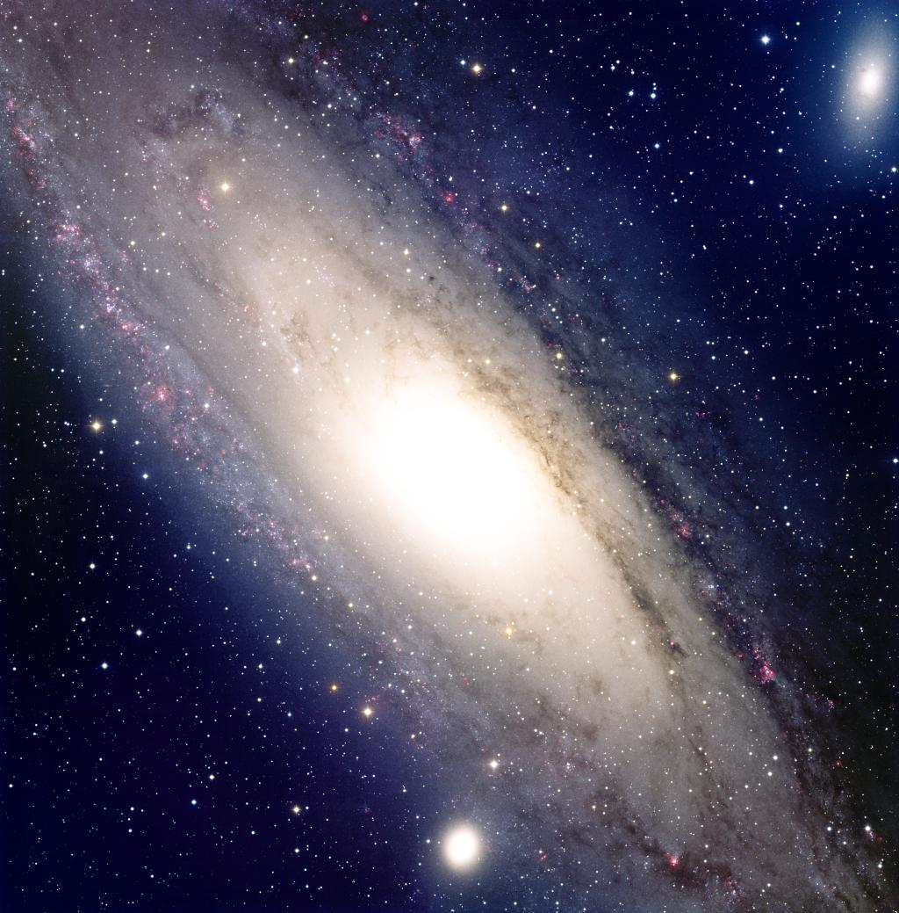
Distances to Objects in the Milky Way Galaxy
Destination | Distance (ly)
Nearest star beyond Sun | 4.2
Sirius | 8.8
Vega | 26
Hyades cluster | 137
Pleiades cluster | 415
Central part of our spiral arm (Orion) | 1300
Orion nebula | 1500
Vertical distance to leave disk | 3300
Next-nearest spiral arm (Sagittarius) | 3900
Center of galaxy | 30,000
M13 globular cluster | 36,000
Far edge of galaxy | 78,000
Source: Hartmann, Astronomy

Types of Galaxies
Name | Symbol | Shapes | Subclasses | Frequency
Elliptical | E | spherical to flat disk;  both giant and dwarf | E0 -> E7+S0: less -> more  flattened | giant 5%  dwarf 50%
Spiral | S | disk w/ spiral arms | Sa -> Sc: smaller center,  more open arms | 20%
Barred spiral | SB | bar connects center  and arms | SBa -> SBc: same tendencies  as regular spirals
Irregular | Irr | no standard shape | none | 25%
5. THE UNIVERSE

What is the universe? Is it "all that is, or ever was, or ever will be" (Carl Sagan)? We don't know. We could define it by Sagan's definition, but that might be misleading. We're inside, and don't know how big it is. The visible part apparently had a beginning at the big bang.

What we do know:

1. The universe is big. The distances to stars are measured in light years (6 trillion miles each) or parsecs (3.26 ly). The distances to globular clusters in thousands of light years (or kiloparsecs), to galaxies in millions of light years (or megaparsecs), the distances to the most distant observable objects (galaxies and quasars) in billions of light years (or gigaparsecs). Thus the universe is at least billions of trillions (i.e., quintillions) of miles in radius.

2. The visible universe cannot be both infinitely large and infinitely old. Because the sky is dark at night! The so-called Olbers' Paradox shows that if the universe is infinitely old and infinitely large (with a reasonably uniform distribution of stars) the light from the stars falling on the earth ought to be infinite or (at least) very bright. Because the sky (ignoring city lights, etc.) is instead rather dark, the stars must come to an end before their images cover every speck of the sky (so the universe is not infinite), OR the really distant stars whose images would cover every speck of the sky have not been burning long enough for their light to get here yet (so the universe hasn't always existed).

3. The visible universe is probably only some 10-20 billion years old. This appears to be the case for several reasons:
a. The most distant objects we can see are only about 10 billion ly away;
b. The age of the globular clusters is some 10-15 billion years;
c. The expansion rate of the universe would suggest that it was once very hot and compact some 10-20 billion years ago;
d. The age of the earth and sun is some 5 billion years, and the sun does not appear to be a first generation star.
4. The universe shows every evidence of being very carefully designed to be able to support life.

The "Fine Tuned" Universe
Item | Consequences if larger | Consequences if smaller
Strong nuclear force constant | no hydrogen | nothing but hydrogen
Weak nuclear force constant | too much He; no heavy elements* | too little He; no heavy elements*
Gravitational force constant | stars too hot, burn too fast | stars too cool, no heavy elements
Electromagnetic force constant | insufficient chemical bonding | insufficient chemical bonding
Ratio of e-m to gravity | no stars less than 1.4 solar masses | no stars more than .8 solar masses
Ratio of electron to proton mass | insufficient chemical bonding | insufficient chemical bonding
Ratio of ## of protons to electrons | e-m dominates grav; no stars | e-m dominates grav; no stars
Expansion rate of universe | no galaxy formation | univ collapses quickly
Entropy level of universe | no proto-galaxy formation | no star formation
Mass density of universe | too much H-2, stars burn too fast | too little He & heavy elements
Velocity of light | stars too luminous | stars not luminous enough
Age of universe | no solar-type stars in right places | solar-type stars not yet formed
Initial uniformity of radiation | stars, clusters, galaxies not formed | universe mostly black holes
Fine structure constant | DNA doesn't work; stars too small | DNA doesn't work; stars too large
Average distance betw galaxies | insuff gas to continue star formation | sun's orbit too disturbed
Average distance betw stars | too few heavy elements for planets | planetary orbits unstable
Decay rate of proton | life exterminated by decay radiation | insuff matter for life
Energy level ratio C-12 to O-16 | insufficient oxygen | insufficient carbon
Ground state energy level of He-4 | insufficient O and C | insufficient O and C
Decay rate of Beryllium-8 | stars explode catastrophically | no elements heavier than Be
Mass excess: neutron over proton | n's decay, too few heavy elements | p's decay, stars collapse
Initial excess nucleons to anti-nuc | too much rad for planet formation | not enough matter for stars
Polarity of water molecule | heat of fusion, vap too gt for life | heats too small; ice won't float
Ratio of exotic to ordinary matter | univ collapse before solar-type stars | no galaxies formed
*outside stars; source: Ross, Creator and Cosmos, 118-121.

5. Our earth-sun environment appears to be unique and even designed. The following characteristics of a planet, its moon, its star, its galaxy, must have values falling within narrowly defined ranges for life of any kind to exist.

1. galaxy type
too elliptical: star formation ends before enough heavy elements for life chemistry
too irregular: radiation exposure too high on occasion, heavy elements for life chem not available

2. supernova eruptions
too close: life on planet exterminated
too far: not enough heavy elements to form rocky planets
too frequent: life on planet exterminated
too infrequent: not enough heavy elements to form rocky planets
too late: life on planet exterminated
too soon: not enough heavy elements to form rocky planets

3. white dwarf binaries
too few: insuff fluorine for life chemistry to proceed
too many: planetary orbits disrupted
too soon: not enough heavy elements to make fluorine
too late: flourine formed too late to be incorporated into planet

4. parent star distance from center of galaxy
farther: heavy elements insuff for rocky planets
closer: too much galactic radiation; planetary orbits disturbed by large number of stars

5. number of stars in planetary system
more than one: plantary orbits disrupted
less than one: not enough heat for life

6. parent star birth date
more recent: star not yet in stable-burning phase; too many heavy elements
less recent: not enough heavy elements

7. parent star age
older: luminosity would change too quickly
younger: luminosity would change too quickly

8. parent star mass
greater: luminosity too variable; star burns too rapidly
less: life zone too narrow; tides slow rotation too much; uv radiation insufficient for photosynthesis

9. parent star color
redder: photosynthesis too weak
bluer: photosynthesis too weak

10. parent star luminosity change
increases too soon: runaway greenhouse effect
increases too late: runaway glaciation

11. planet's surface gravity
larger: atm retains too much ammonia, methane
smaller: atm loses too much water

12. planet's distance from parent star
further: too cool for stable water cycle
closer: too warm for stable water cycle

13. inclination of planetary orbit
too great: temperature differences too extreme

14. eccentricity of planetary orbit
too great: seasonal temperature differences too extreme

15. axial tilt of planet
greater: surface temperature differences too great
less: surface temperature differences too great

16. rotation period of planet
longer: diurnal temperature differences too great
shorter: wind velocities too great

17. rate of change in rotation period
larger: surface temperature range necessary for life not sustained
smaller: surface temperature range necessary for life not sustained

18. age of planet
too young: planet would rotate too rapidly
too old: planet would rotate too slowly

19. magnetic field of planet
stronger: electromagnetic storms too severe
weaker: insuff protection for land life from hard radiation from sun and stars

20. thickness of planet's crust
thicker: too much oxygen lost to crust
thinner: too much volcanic & tectonic activity

21. reflectivity of planet
greater: runaway glaciation
less: runaway greenhouse

22. collision rate with asteriods and comets
greater: too many species wiped out
less: too few minerals needed for life in crust

23. ratio of oxygen to nitrogen in atmosphere
larger: advanced life functions proceed too quickly
smaller: advanced life functions proceed too slowly

24. carbon dioxide level in atmosphere
greater: runaway greenhouse effect
less: plant photosynthesis too low

25. water vapor level in atmosphere
greater: runaway greenhouse effect
less: too little rainfall for advanced land life

26. atmospheric electric discharge rate
greater: too much destruction from fire
less: too little nitrogen fixed in soil

27. ozone level in atmosphere
greater: surface temperatures too low
less: surface temps too high; too much uv at surface

28. quanity of oxygen in atmosphere
greater: plants, hydrocarbons burn too easily
less: too little for advanced animals to breathe

29. activity of tectonic plates
greater: too many life forms destroyed
less: nutrients lost by river runoff not recycled

30. ratio of oceans to continents
greater: diversity, complexity of life forms limited
smaller: diversity, complexity of life forms limited

31. global distribution of continents (for Earth)
too much in So hemisphere: seasonal temperature differences would be too severe for advanced life

32. soil mineralization
too nutrient poor: diversity, complexity of life forms limited
too nutrient rich: diversity, complexity of life forms limited

33. gravitational interaction of planet with moon
greater: tidal effects on oceans, atmosphere and rotation period would be too severe
less: climatic instability; movement of nutrients betw continents and oceans restricted; magnetic field too weak

Probability of getting all these in right range for a given planet is 1 in 10 to 53rd power!

Source: Ross, Creator and Cosmos, 131-145.

