David Wilkerson's Vision and Deuteronomy 18
Robert C. Newman
March 1976

Introduction

The rise of the neo-Pentecostal movement in recent years has once again brought to the attention of Christians the question whether or not there are or have been miraculous gifts in the church since the close of the apostolic period. Each time this question has arisen, those claiming such gifts have tended to charge their opponents with disobedience and lack of faith, whereas those rejecting these gifts have either denied that they were miraculous, pointing to the generally elusive nature of the more spectacular cases, or else admitted they were miraculous and ascribed them to Satan.

Prophecy has usually formed (at least) a small but very significant class of the gifts claimed in such controversies, and this is no exception today. Now prophecy, in principle, has a somewhat more objective nature than either tongue-speaking or healings usually do. That is, a prophecy may be published and thus widely disseminated in advance of its fulfillment. In such a case, an investigator need not be present at the time of the prophecy, as would be the case for healing or tongue-speaking, nor need he have specialized linguistic or medical knowledge, nor direct information on the case history of the person who has been healed. Instead, a person with no special privileges of location or training may himself test various claims to a gift of prophecy, so long as (A) the prophecy is (1) published in advance, (2) clear enough that a real fulfillment may be recognized, and (3) not totally dependent on a Biblical prophecy; and (B) the fulfillment is (1) public enough to be reported by others than the prophet and his partisans, (2) unusual, detailed and remote enough to rule out anything less than a fantastic guess, and (3) not directly fulfilled by the prophet or his friends.

In February of 1974, David Wilkerson, one of the best-known Pentecostal figures in this country, published a book entitled The Vision, in which he set forth the contents of a vision he claimed to have received from God in April of 1973. Basically, the book predicts continued apostasy and moral decay, economic distress, increasing persecution of believers, and various natural calamities, all to occur "in this generation," including (apparently) the second coming of Christ.

Although a great deal of Wilkerson's material seems to be drawn from the Bible (not, indeed, as Post- or A-millennialists would understand it!), The Vision should not be viewed as a Pentecostal version of The Late, Great Planet Earth. Whereas Lindsey claims to derive his material totally from Scripture, Wilkerson repeatedly asserts that his information comes directly from God. The Biblical quotations used in the front matter of his book implicitly compare Wilkerson's vision with those of Paul, Peter, Daniel and Habakkuk, while in the text proper he twice compares his vision with Noah's and suggests from Acts 2:17 (citing Joel 2:28) that the Bible predicts just such visions today. On one occasion Wilkerson says, "I am not preaching now; I am prophesying."

I propose, therefore, to examine the question of miraculous gifts today in the light of this claimed prophetic revelation by an outstanding Pentecostal leader. Naturally, if it should appear that Wilkerson's claims do not stand careful scrutiny, it would not follow that all such claims are invalid. Yet it should serve to put both Pentecostals and non-Pentecostals on guard against credulity and presumption, and to remind us of our responsibility to "test all things, holding fast to that which is good" (1 Thess 5:21).

Tests for a True Prophet

Because of the substantial authority which God gave to the OT prophets, there was a continual temptation for someone to pretend to such a gift. Foreseeing this problem, God established a death penalty for false prophecy in Deut 18:20. As the people were apparently expected to enforce this punishment, the question naturally arose, "How do we recognize a false prophet?" God answered this question by providing two basic criteria.

The prophet must, first of all, agree with previous divine revelation on the subjects he discusses. Thus Deut 13:1-5, for instance, warns against prophets who would seek to lead the believer to follow other gods. It should not be assumed that the prophet would necessarily tell you that this is what he intends, for an entirely different religion may be constructed around orthodox terminology. Recall that even when Israel worshiped the golden calf in the wilderness, Aaron sought to represent the action as "a feast to the Lord" (Ex 32:5). In fact, Paul warns that even an apostle or angel should be considered hell-bent if he brings a gospel that departs from God's provision of salvation by grace alone (Gal 1:8-9). This criterion places a heavy responsibility on every believer to know God's word and to test all teaching by it.

Yet there is always the possibility that we have misunderstood the Scripture at some point, so that a true prophet would naturally disagree with us on this matter. We should, therefore, be willing to give such a fellow the same sort of hearing we would like others to give us when we point out their theological errors! That is, we should be willing to re-examine our own beliefs in the light of Scripture to see whether our view or his best fits God's word. Obviously the Pharisees would have done well to give Jesus such a hearing.

The second criterion for a true prophet is the fulfillment of his predictions. Deut 18:22 gives this test explicitly as God's answer to the people's question, "How will we know the word which the Lord has not spoken?"

That which the prophet speaks in the name of the Lord and the word does not happen nor come about, that is the word which the Lord has not spoken. The prophet has spoken it in presumption; you shall not be afraid of him.

Isaiah 44:24-28 shows us why this test will work. God promises us that He will make fools of false prophets, but that He will uphold the predictions of His true messengers. Thus one false prediction will prove that the prophet is not from God.

Here, too, the Biblical criterion may not be as simple as it first appears. What about Jonah's prophecy that Nineveh would be overthrown in forty days (Jonah 3:4)? Was it not falsified by the events? Some interpreters have suggested that God will occasionally give predictions of judgment which are actually conditioned by the repentance of the recipients, although the condition is not stated in order to make the presentation more forceful. This is a possibility in Jonah's case, yet we should realize that we may not have the complete text of his preaching to the Ninevites. For some reason Jonah feared (Jonah 4:2) and the Ninevite king hoped (Jonah 3:6-9) that God's judgment would be averted if the people repented. In any case, it is not good exegetical methodology to allow a problem passage which is capable of various interpretations to control the meaning of a clear and basis passage such as Deuteronomy 18, where the prophetic office is first established. This is particularly so in view of God's statement in Isaiah 44 and the examples of Micaiah (1 Kings 22:15-37, esp. v. 28) and Jeremiah (Jer 28, esp. vv. 15-17).

Short-Range Prophecies in The Vision

As indicated above, all the prophecies in The Vision are claimed to be short-range predictions in the sense that all are to happen "in this generation"; yet some of the statements include even shorter time-indications. Several have the phrase "in the next decade" attached to the prediction. For instance:

… I see great riots coming to many major cities in South American. In the next decade, South America will become a powder keg, exploding in all directions.

Regarding the weather, Wilkerson says:

Nature will unleash its fury with increasing intensity over the next decade. There will be short periods of relief, but almost every day mankind will witness the wrath of nature somewhere in the world. Those record-breaking changes will be above and beyond anything experienced in the past.

After speaking of "floods, hurricanes, tornadoes," bad flying conditions, "the most violent winters of all times," earthquakes, and epidemics, he continues:

The drastic weather changes that are coming in the next decade will bring with them violent hailstorms of unbelievable proportions. Large chunks of ice will fall from the sky and cause much damage. The storms will not only destroy crops and smash automobiles, but they will also cause the death of many people.

These events are quite explicit and should form an excellent test for Wilkerson's Vision. There is a slight ambiguity in the term "next decade," however. Does he mean within ten years of the vision (i.e., by April, 1983) or does he mean we are in the decade of the 1970s, so the events will occur in the 1980s (before 1990)?

Another prophecy is to be fulfilled "soon." In the context of a book which says –

Parts of this vision will come to pass in the very near future. Some of the events are more distant. But I believe all the events mentioned will happen in this generation!

– "soon" would seem to be within a few years or a decade. The prophecy in question is:

The United States is going to experience, in the not-too-distant future, the most tragic earthquake in its history. One day soon this nation will be reeling under the impact of the biggest news story of modern times. It will be coverage of the biggest, most disastrous earthquake in history.

On the same page, Wilkerson says it will be far worse than the San Francisco earthquake, and it probably will not occur in California. This prophecy, too, should be easily testable.

Other prophecies speak of events occurring in "the next few years." Since "few" means "not many," "a small number," these events would seem to be very close, presumably well within ten years. Thus:

Floods, hurricanes, tornadoes, and hailstorms will occur more frequently. More than one-third of the United States will be designated a disaster area within the next few years.

It is one of these "next few years" predictions that gives us the only passage in The Vision which can with some assurance be falsified already at the time of writing of this paper (March, 1976). In his first chapter, "Economic Confusion," Wilkerson titles the second section "A Few Good Years to Prepare." There he says:

In spite of all the danger signs around us of impending economic disaster, the next few years (from 1973) will be among the most prosperous in the history of mankind.

We have already examined the meaning of the adjective "few" above, but it is also important to consider the adverb "next" which here modifies "few." According to Webster's Dictionary, "next" means "in the time, place or order nearest or immediately succeeding." Thus, the small number of years immediately following 1973 should be "among the most prosperous in the history of mankind." Let us look at various economic indicators for the period since April 1973 to see whether or not this is so.

The Economic Situation since April 1973

One of the most important economic indicators in our country is the condition of prices on the stock exchange. There are several formulae which have been designed to reflect this condition. The Dow-Jones Industrial Average is one such formula, and it is given below (figure 1) for the years 1934 through 1975.

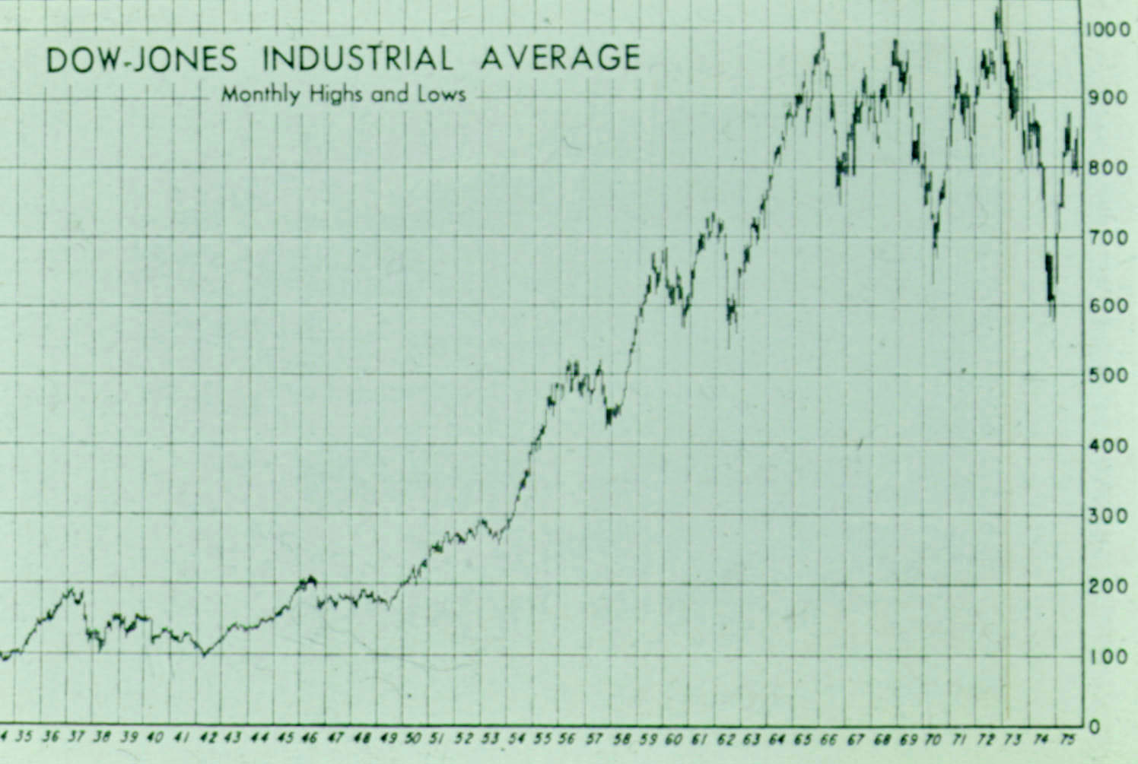
Figure 1:

Dow-Jones Industrial Average 1934-1975. Source:
Moody's Handbook of Common Stocks (Winter, 1976), p 27a.

Notice that from the beginning of 1973 to the end of 1974, the Dow-Jones average fell further than it has ever fallen in its entire history, from well over 1000 to less than 600! It is true that the percentage decrease is not as severe as in the Great Depression, but there has been nothing comparable since then. Nor is this a peculiarity of this one formula alone. The other major stock market indices, Standard and Poor's Average of 500 Stocks, the New York Stock Exchange Composite Index, and the American Stock Exchange Market Value Index, give the same picture. So far, the next few years from 1973 have been very bad at the stock exchange.

Of course, not everyone trades on the stock exchange, but problems there usually mean bankruptcies and production cutbacks which affect the wage-earner also.

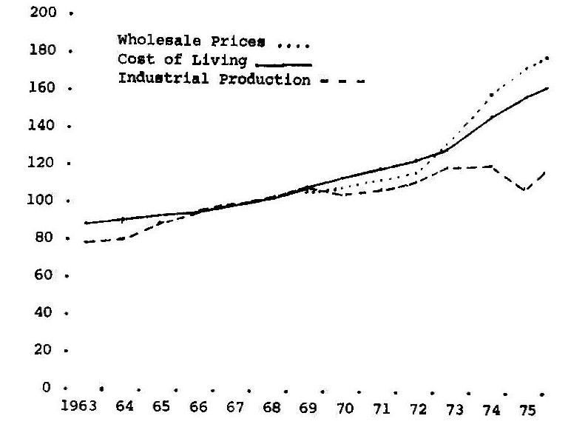

Figure 2: Wholesale Prices, Cost of Living Index, and Total Industrial Production on scale 1967 = 100. Data from Standard and Poor's Security Owner's Stock Guide 30, no. 1 (Jan 1976), 258.

As figure 2 indicates, industrial production since April, 1973 has declined noticeably, while wholesale prices and the cost of living indicate that inflation has begun to rise even more rapidly than in the preceding years. This has resulted in a serious unemployment problem in 1974 and 1975, with more than twice as many people out of work at the end of 1975 than at the end of 1973. See figure 3, below. So far, the few years following 1973 have been bad for both the worker and his employer.

Even though the total personal income in the United States has continued to rise steadily, and most persons with jobs are getting more pay than ever before, the combination of increasing population and rising cost of living mean that the income per person in real dollars has fallen off measurably since reaching a peak at the end of 1973. See figure 3.
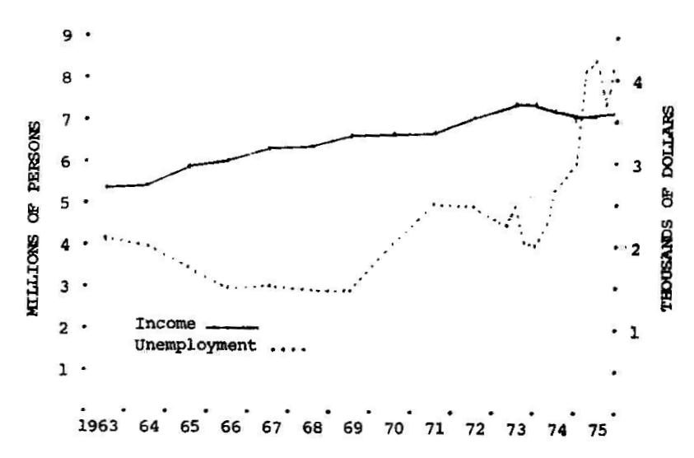

Figure 3: Per Capita Income Adjusted to the Buying Power of the Dollar in 1967; Number of Persons Unemployed. Data from Standard and Poor's Security Owner's Stock Guide 30, no. 1 (Jan 1976), 258, and Bureau of the Census.

Thus, again, we find that the few years following 1973 have so far been rather bad in terms of buying power.

Conclusions

We have examined several prophecies in Wilkerson's Vision, and found that only one of them is amenable to test as of March, 1976. It looks very much like this prophecy has failed.

It is, of course, possible to avoid this conclusion by one of several means. For instance, one may claim that the prophecy refers to the world as a whole rather than the United States in particular. Definite figures would then be much more difficult to obtain. However, the impressions conveyed by the news media suggest that most countries of the world are more severely affected by inflation than we are, especially Europe and the developing nations, as a result of the sharp rise in oil prices.

Alternatively, one may claim that our present economic situation is still good enough to put us "among the most prosperous [years] in the history of mankind," even though we may be somewhat past the peak. This is certainly true for the US, though it may not be so for Europe and the third world. But this whole interpretation seems rather forced in view of the phrases "fat and flourishing years" and "years of tremendous affluence" which occur on the same page, not to mention Wilkerson's later remark:

The number one temptation for the last [generation] Christian will be prosperity …. I see millions of Christians being deceived by prosperity. The last Christian is going to be afflicted by prosperity and tested by it more than through poverty.

These all sound as though the best years economically were thought by Wilkerson to be still ahead in 1973.

Perhaps, then, the word "few" should be understood to mean "eight or ten," and 1973-75 is merely a little slump at the beginning of "the next few years" which will not count when you average over the whole span. Thus the next eight or ten years could still be "among the most prosperous in the history of mankind." But that, indeed, remains to be seen.

There are, you see, several possible ways to escape the conclusion that David Wilkerson's Vision is not from God, yet at the present time, the prediction we have examined gives every indication of being in error.

In stating this conclusion (and in writing this paper), I do not wish to give the impression that I consider David Wilkerson an unbeliever, or that I deny that God may have used him for important work in the inner city. Rather I have examined his book in order to warn those who believe they have miraculous gifts: Be sure you have them, lest you not only make a fool of yourself, but you also bring disrepute upon the precious name of our Savior!

A Note Added November, 2008

In the process of putting a number of my old papers in electronic form for posting to the IBRI website, it is interesting to look back at this one from over thirty years later.

Wilkerson's prediction of prosperity for the years following 1973 looks pretty good in the context of thirty years. These have been fat and prosperous years, and unprecedented in history. There is still that glitch in 1973-75, immediately following his vision. It almost looks like God was sending us (and Wilkerson) a signal that all was not well with his predictions. Whether the recent economic problems of 2008 will lead to disaster or just be another glitch, only time will tell. I will not try my hand at prophecy!

Wilkerson's other predictions, for "the next decade" (pages 3-4, above) have failed rather disastrously, in spite of the fact that the world has had a striking number of catastrophes in the closing years of the 20th century and the opening years of this one. See my discussions in "The Birth Pains of the Messiah" and "How Near is the End?" I don't intend to speculate on how close the end is, but I will warn my readers that the God of the Bible does exist, and his offer of forgiveness will one day come to an end. For the world as a whole, we don't know how long this will be; it might be only a few years; it might be centuries. For us as individuals, the offer of forgiveness will end when we die, if we haven't taken God's remedy in Jesus to heart. May God give you grace to do so!

David Wilkerson, The Vision (New York: Pyramid Books and Old Tappan, NJ: Fleming Revell, 1974). The pagination of both editions is the same.
Ibid., 12.
Ibid., 35, 93.
Hal Lindsey, The Late, Great Planet Earth (Grand Rapids: Zondervan, 1970; reprinted, New York: Bantam Books, 1973).
Ibid., vii-viii, Bantam edition.
Vision, 6.
Ibid., 9.
Ibid.
Ibid., 7.
Ibid., 13, 96.
Ibid., 13.
Ibid., 68.
More detailed discussions of tests for true and false prophets may be found in the Zondervan Pictorial Encyclopedia of the Bible, s.v., "Prophets and Prophecy," by Allan A. MacRae; and in J. Barton Payne, Encyclopedia of Biblical Prophecy (New York: Harper and Row, 1973), 59-91.
Vision, 26-27.
Ibid., 36.
Ibid., 39.
Ibid., 12.
Ibid., 32.
Ibid.
Webster's Third New International Dictionary, 843.
Vision, 35.
Ibid., 16.
Webster's Third New International Dictionary, 1524.
Standard and Poor's Security Owner's Stock Guide 30, no. 1 (Jan 76), 1.
Moody's Handbook of Common Stocks (Winter, 1976), 29a.
Ibid., 30a.
Vision, 54, 55.

