New Testament

Backgrounds

Notes for NT601 New Testament Backgrounds

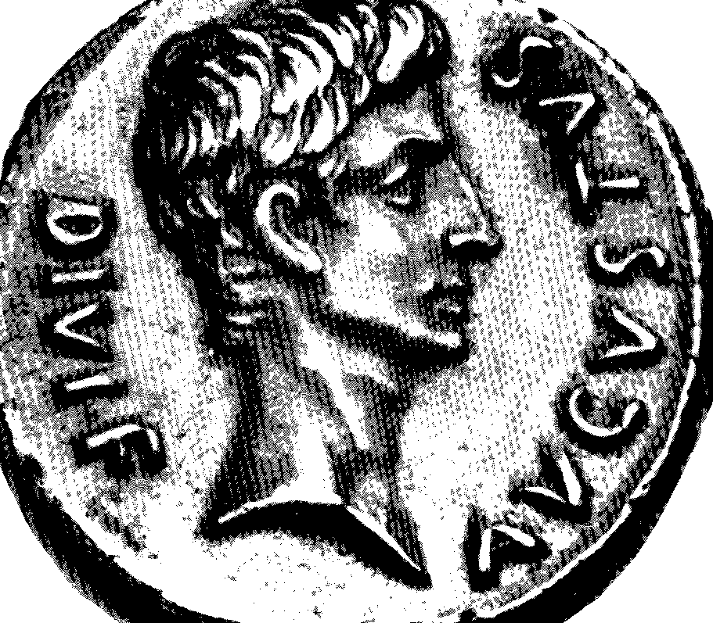

Prepared by
Robert C. Newman
Professor of New Testament

Copyright 1991

This syllabus or parts thereof may not be reproduced in any form without permission from the author. Permission will be granted to reviewers, authors, teachers and others engaged in the promotion of biblical studies.

Biblical Theological Seminary
200 N. Main Street
Hatfield, PA 19440

TABLE OF CONTENTS

BIBLIOGRAPHY FOR THE COURSE 5

PART ONE: HISTORY: THE INTERTESTAMENT PERIOD 7

I. INTRODUCTION 7

A. Our Sources of Information 7
B. Daniel's Overview 8

II. PALESTINE UNDER PERSIA (539-331 BC) 9

A. History of the Medo-Persian Empire 9
B. The Aramaic Language 9
C. Synagogue & Temple 10

III. PALESTINE UNDER THE GREEKS (331-c160 BC) 11

A. Alexander and His Successors 11
B. Hellenism 12
C. The Septuagint Translation 12

IV. JEWISH INDEPENDENCE UNDER THE HASMONEANS (160-63 BC) 13

A. Antiochus 4 & the Abomination of Desolation 13
B. The Maccabean Revolt 13
C. The Hasmonean Dynasty 14
D. Pharisees, Sadducees & Essenes 15

V. PALESTINE UNDER THE ROMANS (65 BC-135 AD & beyond) 16

A. End of the Hasmonean Dynasty 16
B. The Herod Family 16
C. Messianic Expectation 17
D. The End of the Jewish State 18
E. Palestine after the Fall of Jerusalem 19

PART TWO: NEW TESTAMENT GEOGRAPHY & CHRONOLOGY 20

I. THE GEOGRAPHY OF PALESTINE 20

A. Physical Features 20
B. Political Features 22

II. THE GEOGRAPHY OF JERUSALEM 223

A. The Valleys around Jerusalem 23
B. The Hills around Jerusalem 24
C. The City Walls of the NT Period 24
D. Sections of the City 24
E. Major Buildings, Structures 25
F. Other Sites re/ Jesus' Ministry 26

III. MEDITERRANEAN GEOGRAPHY 26

A. Physical Features 26
B. Political Features 27

IV. THE CHRONOLOGY OF THE NEW TESTAMENT 29

A. Origin of the Christian Era 29
B. Gospel Chronology 30
C. Apostolic Chronology 31

PART THREE: NEW TESTAMENT CULTURE & ARCHAEOLOGY 35

I. MONEY 35

A. History of Money 35
B. Money in N.T. Times 35
C. Inscriptions & Designs on NT Money 36

II. THE HOME 38

A. Clothing 38
B. Housing 38
C. Agriculture 39

III. SOCIETY 40

A. Buildings, Architecture 40
B. Cities 40
C. Business 41
D. Transportation 41
E. Religion 42

IV. INTRODUCTION TO ARCHAEOLOGY 42

A. Definition of Archaeology 42
B. Methods of Archaeology 43
C. Some Archaeological Sites of the NT Period 44
1. Jerusalem (44)
2. Capernaum (45)
3. Caesarea (45)
4. Herodium (47)
5. Masada (48)
6. Corinth (49)
7. Rome (50)

BIBLIOGRAPHY FOR THE COURSE

BIBLIOGRAPHIES
Danker, Frederick W. Multipurpose Tools for Bible Study. St. Louis: Concordia, 1960.
Harrington, Daniel J. The New Testament: a Bibliography. Theological and Biblical Resources, vol. 2. Wilmington, DE: Michael Glazier, 1985.
Hort, Erasmus. The Bible Book: Resources for Reading the New Testament. New York: Crossroad, 1983.
Hurd, John C. A Bibliography of N.T. Bibliographies. Seabury, 1966.
Scholer, David M. A Basic Bibliographic Guide for N.T. Exegesis. 2nd ed. Grand Rapids: Eerdmans, 1973.
Thiselton, Anthony C. New Testament Commentary Survey. Revised by Don Carson. Leicester, England: Theological Students Fellowship, 1977.

HISTORY
Barrett, C.K. The New Testament Background: Selected Documents. New York: Harper and Row, 1961.
Bonsirven, Joseph. Palestinian Judaism in the Time of Jesus. New York: Holt, Rinehart and Winston, 1964.
Bruce, F.F. Israel and the Nations. Grand Rapids: Eerdmans, 1963.
________. New Testament History. New York: Doubleday, 1969.
Ferguson, Everett. Backgrounds of Early Christianity. Grand Rapids: Eerdmans, 1987, 1993.
Foerster, Werner. From the Exile to Christ. Philadelphia: Fortress, 1964.
Gowan, Donald E. Bridge Between the Testaments. Pittsburgh: Pickwick, 1976.
Jaegersma, Henk. A History of Israel from Alexander the Great to Bar Kochba. Philadelphia: Fortress, 1986.
Kee, Howard Clark. The New Testament in Context: Sources and Documents. Englewood Cliffs, NJ: Prentice-Hall, 1984.
Lohse, Eduard. The New Testament Environment. Nashville: Abingdon, 1976.
Pfeiffer, Charles F. Between the Testaments. Grand Rapids: Baker, 1959.
Reicke, Bo. The New Testament Era. Philadelphia: Fortress, 1968.
Rostovzeff, M. Greece. New York: Oxford, 1963 reprint of 1930.
________. Rome. New York: Oxford, 1960 reprint of 1928.
Vermes, Geza. The Dead Sea Scrolls in English. 2nd ed. Baltimore: Penguin, 1965.
Whiston, William, ed. Josephus: Complete Works. Grand Rapids: Kregel, 1960.

GEOGRAPHY & CHRONOLOGY
Aharoni, Yohanan and Avi-Yonah, Michael. The Macmillan Bible Atlas. 2nd ed. New York: Macmillan, 1977.
Baly, Denis. Basic Biblical Geography. Philadelphia: Fortress, 1987.
________. The Geography of the Bible. New York: Harper and Bros., 1957.
Cleave, Richard and Monson, James. Student Map Manual: Historical Geography of the Bible Lands. Grand Rapids: Zondervan, 1980.
Finegan, Jack. Handbook of Biblical Chronology. Princeton: Princeton Univ Press, 1964.
Frank, Harry T. Atlas of the Bible Lands. rev. ed. New York: Hammond, 1984.
Hoehner, Harold. Chronological Aspects of the Life of Christ. Grand Rapids: Zondervan, 1977.
Rasmussen, Carl G. NIV Atlas of the Bible. Grand Rapids: Zondervan, 1989.
Smith, George Adam. Historical Geography of the Holy Land. 16th ed. London: Hodder and Stoughton, 1910.

CULTURE & ARCHAEOLOGY
Avi-Yonah, M. and Stern, E., eds. Encyclopedia of Archaeological Excavations in the Holy Land. 4 vol. Englewood Cliffs, NJ: Prentice-Hall, 1975.
Blaiklock, Edward M. The Archaeology of the New Testament. Grand Rapids: Zondervan, 1970.
________ and Harrison, R.K., eds. The New International Dictionary of Biblical Archaeology. Grand Rapids: Zondervan, 1983.
________. The World of the New Testament. London: Ark and Ft. Washington: Christian Literature Crusade, 1983.
Daniel-Rops, Henri. Daily Life in the Time Of Jesus. New York: Hawthorne, 1962.
Edersheim, Alfred. Sketches of Jewish Social Life in the Days Of Christ. London: James Clarke, 1961 reprint of 1883.
Finegan, Jack. The Archaeology of the New Testament: The Life of Jesus & the Beginning of the Early Church. Princeton: Princeton Univ Press, 1969.
________. The Archaeology of the New Testament: The Mediterranean World of the Early Christian Apostles. Boulder, CO: Westview, 1981.
Gorsline, Douglas. What People Wore: A Visual History of Dress from Ancient Times to 20th-Century America. New York: Bonanza, 1952.
Jeremias, Joachim. Jerusalem in the Time Of Jesus. Philadelphia: Fortress, 1967.
Landels, J. G. Engineering in the Ancient World. Berkeley: Univ of California Press, 1978.
Mare, W. Harold. The Archaeology of the Jerusalem Area. Grand Rapids: Baker, 1987.
Metzger, Bruce M. Lexical Aids to Students of N.T. Greek. new ed. Princeton, NJ: published by author, 1977.
Murphy-O'Connor, Jerome. The Holy Land: An Archaeological Guide from Earliest Times to 1700. New York: Oxford, 1980.
Packer, J.I., Merrill C. Tenney and William White, Jr. The World of the New Testament. Nashville: Nelson, 1982.
Pfeiffer, Charles F., ed. The Biblical World: A Dictionary Of Biblical Archaeology. Grand Rapids: Baker, 1966.
Ramsay, William M. The Cities of St. Paul. Grand Rapids: Baker, 1960 reprint of 1907.
Stephens, William H. The New Testament World In Pictures. Nashville: Broadman, 1987.
Stevenson, James. The Catacombs: Life and Death in Early Christianity. Nashville: Thomas Nelson, 1985.
Tenney, Merrill C. New Testament Times. Grand Rapids: Eerdmans, 1965.
Unger, Merrill F. Archaeology and the New Testament. Grand Rapids: Zondervan, 1962.
Yamauchi, Edwin. The Archaeology of New Testament Cities in Western Asia Minor. Grand Rapids: Baker, 1980.
________. Harper's World of The New Testament. New York: Harper and Row, 1981.

PART ONE:
HISTORY: THE INTERTESTAMENT PERIOD
(THROUGH THE BAR KOCHBA WAR)

I. Introduction

A. Our Sources of Information for the Period

1. OT Prediction
Daniel gives an overview of the period thru visions in chap 2 (statue) and ch 7 (4 wild animals); see below
Also gives some details, in Dan 8, 9 & 11 especially

2. OT Apocrypha & Pseudepigrapha
Religious writings of Jews, mostly during IT period
Some posing as Scripture, some not
Give insight into culture, religious ideas, sects, Biblical interp during period
1 Maccabees esp important re/ history of revolt;
2 Macc also adds valuable information, though considered somewhat less reliable

3. Philo
Born c 20 BC, died after AD 40
Alexandrian Jew, member of very prominent family
Studied Greek philosophy, tried to amalgamate OT w/ selected ideas from Gk philosophy
Influential among Christians in allegorizing Scripture
Shows one variety of Jewish reaction to Hellenism, namely partial accommodation

4. Josephus
Born AD 37, died after 100
Pharisee, member of very prominent Jerusalem family
Involved on both sides of Jewish war 66-73
Wrote Jewish War at request of Vespasian/Titus, c 80
Wrote Antiquities to show Jews were ancient race, c 95
Both cover IT period & NT period, using some sources no longer extant

5. Dead Sea Scrolls
Literature written/copied by Qumran sect, apparently a variety of Essenes
Stricter than Pharisees, but wrote some "Scripture" of their own
Show eschatological interests of Jews at time

6. Rabbinic Literature
Oral traditions of rabbis
Midrash(im) - tradition textually organized
Mishnah, Gemara, Talmud - topically organized
Not much historical; mostly written centuries later
But give flavor & details of Pharisaic theology, ethics, practice; much on temple practice in last generation or so before AD 70

B. Daniel's Overview of the Inter-Testament Period

1. Nebuchadnezzar's Image (Dan 2)
a. Pictured (vv 32-35)
(0) Statue & action
(1) Head of Gold (v 32)
(2) Breast & Arms of Silver (32)
(3) Belly & Sides of Bronze (32)
(4) Legs of Iron (33)
(5) Feet, part Iron, part Clay (33)
(6) Stone smashes image, grows to fill earth (34-35)
b. Explained (vv 38-45)
(0) What will happen hereafter (45)
(1) Nebuchadnezzar's universal rule (38)
(2) Another kingdom inferior (?) to Neb's (39)
(3) 3rd kingdom to rule over all the earth (39)
(4) 4th kingdom strong as iron, breaking (40)
(5) The same (?), part strong, part broken (41-3)
(6) God will set up a permanent kingdom (44)

2. Daniel's Four Wild Animals (Dan 7)
a. Pictured (vv 3-14, more details in 19, 21-23)
(0) Diverse beasts from sea (3)
(1) lion w/ eagle's wings; plucked, lifted, heart (4)
(2) bear raised on one side; 3 ribs in mouth (5)
(3) leopard, 4 wings, 4 heads (6)
(4) dreadful, terrible, iron teeth, bronze claws, 10 horns, 11th rises, wars w/ saints (7-8, 19,21-22)
(5) 4th destroyed, dominion given to son of man (9-14)
b. Explained (17-26)
(0-4) 4 kings who will arise from earth (17)
(4) 4th kingdom, diverse from others; horns = kings; wears out saints for 3½ times (23-26)
(5) Saints take kingdom & possess it forever (18)

3. The Kingdoms
a. Babylon (609-539 BC)
b. Medo-Persia (539-331 BC) \ will use these
c. Greece (331-30 BC) | three kingdoms
d. Rome (30 BC-present?) / to structure our history

II. Palestine under Persia (539-331 BC)

A. History of the Medo-Persian Empire

1. The Rise of Cyrus
Medes already powerful before 600 BC, helping Babylonians destroy Assyria
Babylonians hold Medes at bay, but begin to weaken with death of Nebuchadnezzar (562)
Cyrus (559) inherits small kingdom of Anshan (later called Persia), tributary to Medes; Bab king Nabonidus provides financial support to harass Medes
Cyrus defeats Medes (550); Nabonidus cancels support!
Cyrus has self crowned king of Medes, forming dual monarchy
Cyrus takes Lydia, rest of Asia Minor (546), then Babylon (539)

2. The Return of the Jews (under Cyrus 1: 539-530)
Unlike Assyrians & Babylonians, Cyrus did not wish to offend other religions
Takes part in New Year ceremony at Babylon (537) to become rightful king of Babylon
Revokes Assyr & Bab deportation policy, allowing Jews to return (Ezr 1:2-4)

3. The Rebuilding of the (2nd) Temple (Darius 1: 521-486)
Cyrus initially allowed rebuilding to start, but stopped it due to opposition of neighbors (Ezr 6:3-5; Ezr 4)
Jews allowed to rebuild temple after showing loyalty at accession of Darius
Temple completed 515 under leadership of prophets Haggai & Zechariah, governor Zerubbabel & high priest Jeshua

4. Revival in Judah & Rebuilding Walls of Jerusalem (Artaxerxes 1: 465-423)
Ezra (c458) comes from Babylonia, restores people to observance of law, w/ permission of king
Nehemiah (445) sent by king as governor w/ permission to rebuild walls

B. The Aramaic Language

1. Old Language of Syria (upper Euphrates)
language of Laban (Gen 31:47; prob Abraham's in Haran)

2. Becomes Diplomatic Language of the Ancient Near East
Assyrian Empire (c700; Isa 36:11)
Babylonian Empire (c600; Dan 2:4)
Persian Empire (c450; Ezra 4:11ff)

3. Adopted by the Jews
apparently during Babylonian exile (see Neh 8:7-8)
still in use at time of Christ (Mk 5:41: talitha kum; 7:34: ephatha)
used in rabbinic Talmud, c550 AD
still used (w/ different script) in Syrian church today

4. Aramaic's Relation to the Bible
a. Aramaic Passages in the Bible
Daniel chs 2-7; most of Ezra chs 4-7
One verse in prophets, Jer 10:11
One word in pentateuch, Gen 31:47
b. The Targums
oral translations of Bible into Aramaic, perhaps dating back to Bab exile
completed & written down after NT times:
Pentateuch: Targum of Onkelos, Palestinian Targum
Prophets: Targ of Jonathan

C. Synagogue & Temple

1. Rise of the Synagogue
place of worship for those unable to attend temple
prayer & Bible study rather than sacrifice
time of origin obscure:
before exile? (Ps 74:8)
most think during exile when no temple
some suggest after Maccabean revolt
continued alongside 2nd temple (515 BC - AD 70)
after destruction of 2nd temple, only place of worship

2. The Intertestament Temples
a. Second (Jerusalem) Temple (515 BC - AD 70)
orthodox, continuation of Mosaic regulations
b. Samaritan (Mt. Gerizim) Temple (450/330 - 128 BC)
Samaritans, w/ help from renegade priests
destroyed by Hasmoneans (Maccabees)
still a holy site in NT times (Jn 4:20) & even today
c. Elephantine (Egyptian) Temple (built before 525 BC;
destroyed 410; prob rebuilt by 402; destroyed c 390 BC)
Jewish mercenaries, poss refugees from Manasseh
polytheistic influence? cp Jer 44:15-19: "Queen of Heaven"
app animal sacrifices before 410 (see BAR May/June 95)
may have gotten help in rebuilding from Jerusalem under stipulation that no animal sacrifice

d. (Later) Leontopolis Temple (c160 BC - AD 72)
built in Maccabean period by refugee high priest Onias 3
destroyed by Romans to eliminate rallying point for Jews

III. Palestine under the Greeks (331-c160 BC)

A. Alexander & his Successors

1. Alexander (336-323)
succeeds assassinated father at age 20 (336)
invades Asia Minor (334) w/ 35,000 men, wins victory at Granicus River.
victory at Issus (333) opens Syria, Palestine, Egypt
victory at Gaugamela (331) destroys Persian empire
marches east to India, finally turning back at demand of soldiers; dies in Babylon planning further conquests
begins important mixing of East & West, including Hellenism (see below) and spread of Greek language

2. The Struggle for Succession (323-301)
Alexander's son still baby at A's death; his brother is incompetent
Generals, keeping throne for son, fall to fighting
Antigonus seems to be headed for complete control (315), but others gang up & kill him in battle of Ipsus (301)
eventually empire broken into several pieces:
Lysimachus ruling Thrace
Cassander ruling Macedonia
Seleucus ruling Asia Minor, Mesopotamia
Ptolemy ruling Egypt & Syria
only latter two important for history of Palestine

3. The Ptolemaic Dynasty (to 30 BC; over Palestine 301-198)
grabbed off Palestine while others defeating Antigonus
reasonably favorable treatment of Jews both in Palestine, Egypt (large no. settle in Alexandria)

4. The Seleucid Dynasty (to 63 BC; controls Pal 198-c160)
in long series of wars finally got Pal from Ptolemies
Antiochus 4 favors Hellenistic Jews, allowing them to establish Jerusalem as Hellenistic city
Ant 4 later attempts to abolish Judaism (168), leading to Maccabean revolt (167)

B. Hellenism

Greek culture as it developed in East after Alexander
Influenced Judaism and (somewhat) influenced by it

1. Religion
syncretism (mixing) of eastern & Greek polytheisms
some attempts to mix with Judaism

2. Philosophy
various schools in Greece spread Eastward
most important: Epicurean, Stoic, Platonic
many Jews adopted various philosophical ideas
e.g., Philo of Alex (selection of platonic, stoic)

3. Politics
independent city-states in Greece
modified in East, as under imperial control of Ptolemies & Seleucids
citizenship - more restricted in numbers than modern citizenship

4. Influence on Jews
growth of Hellenistic Jews, attracted to one or more features of Hellenism; some radical, some moderate
reaction against Hellenism by Hasidim, Jews determined to be faithful to God's covenant

5. Influence of Judaism on Hellenism
Bible translated into Greek
many Gentiles attracted to God of Bible via synagogues

C. The Septuagint Translation

1. Origin of the Version (c250 BC)
a. Letter of Aristeas & its Story
claims to be written by pagan Greek about 250 BC
72 Jewish elders from Palestine come to Egypt & translate Law at commission of Ptolemy 2
b. Later Additions to Story
translation covers whole OT
translators got identical results working in pairs
c. General Opinion of Story Today
Aristeas probably written by Jew about 100 BC
But some features prob authentic:
-translation into Greek made at Alexandria
-Pentateuch translated as a unit about 250 BC
-scrolls (poss translators) from Jerusalem
-Ptolemy 2 allowed work, may have given aid

2. Importance of Version
a. Longest translation of any ancient writing known in antiquity
b. Gives text of OT century or so before oldest Heb texts for most of OT
c. Set pattern for Greek theological terms used in OT & NT
d. Put OT in universal language of Mediterranean
e. Became OT of early church

IV. Jewish Independence under the Hasmoneans (160-63 BC)

A. Antiochus 4 Epiphanes & the Abomination of Desolation

1. Usurps throne from nephew (175), who was under age
2. Strong advocate of Hellenism to unify diverse empire
3. Among Jews favors Hellenistic faction (vs. Hasidim) allows them to refound Jerusalem as "Antiochia"
4. Deposes orthodox high priest Onias 3 for O's Hellenistic brother Jason (for a bribe); then Jason for Menelaus (bigger bribe; not even high priestly family)
5. Fuming from defeat in Egypt (168), Ant 4 finds Jason has rebelled; puts down revolt & tries to destroy Judaism via decrees forbidding circumcision & kosher, destroying Scripture, rededicating temple to Zeus (himself)

B. The Maccabean Revolt (167-134)

1. Origin
Seleucids go through towns of Judea, enforcing Ant 4's decrees and commanding pagan sacrifice
At Modin, aged priest Mattathias kills Jew who comes forward to sacrifice, then official & his few troops
Matt & 5 sons call for armed resistance, flee to mountains

2. Judah the Maccabee (166-160)
3rd son of Mattathias; named leader at M's death
military nickname Macc means "hammer"/ "hammerer"
Judah M leads guerilla campaign, destroying several Sel armies
JM's forces grow w/ success, matching Sel escalation
Antiochus is busy in E, having left Lysias in charge in W
Lysias invades Palestine w/ large army in 164, but army nearly wiped out in ambush at Emmaus
Macc's take Jerusalem (exc citadel), cleanse & rededicate temple (Dec 164); origin of Hannukah (Feast of Lights)
Meanwhile Antiochus 4 dies (163), Lysias becomes regent
Lysias offers peace terms acceptable to Hasidim but not to Macc's, thus splitting opposition
JM, heavily outnumbered, killed in battle (160)

3. Jonathan (160-142)
brother of Judah
escapes defeat w/ a few followers, become guerillas again
but w/ Ant 4's death, successor Demetrius 2 faces challenge for Seleucid throne from Alexander Balas
Jonathan able to use diplomacy skillfully when both sides seek his aid; eventually becomes governor & high priest
finally killed (142) by Trypho, another contender for Seleucid throne

4. Simon (142-134)
last surviving son of Mattathias, succeeds Jonathan
supports Demetrius 2 against Trypho; in gratitude, Dem makes Judea tax-exempt (virtually independent)
Simon proclaimed "gov & high priest forever" until true prophet comes to give further instructions (1 Macc 14:25-49)
son-in-law murders Simon & 2 sons at banquet (134)

C. The Hasmonean Dynasty (134-63)

1. John Hyrcanus (134-104)
son of Simon, not at banquet, succeeds father
becomes powerful militarily, while Seleucids weak
greatly expands Judean territory:
-conquers coastal cities (gaining trade income)
-takes Idumea (Edomites must become Jews or die, fulfilling Ezk 25:14)
-conquers Samaria, destroys Mt. Gerizim temple
Rise of Pharisees & Sadducees
first appear in history during JHs rule
JH originally favors Pharisees, but then dispute occurs and Sadducees gain his favor

2. Aristobolus (103)
oldest son of JH, assumes throne, kills several of own bro's, imprisons another
first Jew to take title "king" since Babylonian conquest
conquers Galilee, leading to settlement of Jews there
dies w/in a year from fear, drink, disease

3. Alexander Jannaeus (102-76)
Arist's bro, released from prison & married by A's wife
AJ continues expansion of kingdom until nearly as big as David & Solomon's
Pharisees revolt, call in Syrians; AJ about to lose when Phar's defect to him; AJ wins, crucifies many Phar's

4. Salome Alexandria (75-67)
wife of A & AJ, succeeds at AJ's death
2 sons:
Hyrcanus 2 - made high priest
Aristobolus 2 - given military command

5. End of Hasmonean Independence (66-63)
Salome dies, succeeded by Hyr 2 (supported by Phar's)
but Arist 2 (supported by Sadd's) takes throne from him
Hyr 2 flees, opens civil war, calls on Romans

D. Pharisees, Sadducees & Essenes

1. Origins
rather obscure, but all 3 apparently arise in this period
Sadd's look like Hellenizers of Antiochus 4's time, but prob new growth under continued influence of Hellenism
Phar's & Essenes app develop from Hasidim, Phar's accept, Essenes reject, arrangements of temple & esp priesthood during Macc period

2. Theology:

Essenes | Pharisees | Sadducees
Name from hasid? | Names from parash? | Name from tsedek?
Super Pharisees, abandoned temple | Ritual purity, hedge around Law | More pragmatic, compromising
Calvinistic | Calvinistic | Arminian
OT + own secret books | OT + oral tradition | OT only
Immortality of soul? | Bodily resurrection | No survival
Emphasis on angels | Belief in angels | No angels
Emphasis on eschatology | Last judgment | No judgment

3. Influence & Survival

Essenes | Pharisees | Sadducees
Few, more or less withdrawn | Not large, but popular support | Few richest families, especially chief priests
Withdrawn from politics, too | Important politically, dominant religiously | Dominant politically, but had to cooperate with Pharisees
Qumran destroyed AD 68, some later influence | Survive to dominate Judaism after AD 70 | Destroyed with temple in AD 70
Wrote or copied Dead Sea Scrolls | Rabbinic literature by their heirs | No known writings survive

V. Palestine under the Romans (63 BC-135 AD & beyond)

A. The End of the Hasmonean Dynasty (63 BC)

1. Civil War between Hyrcanus 2 & Aristobolus 2

2. Pompey Intervenes
Roman triumvir in E, mopping up Seleucid empire
Called in to arbitrate, decides in favor of Hyr
When resisted by Arist's forces, takes Jerus
Many Jews taken slaves, scattered thru Rom Emp
Judaea loses much of its conquered territories
Hyr 2 made "ethnarch" of Judea (incl Idumea, Perea, Galilee) rather than king

3. The Pax Romana (c30 BC-c170 AD)
2 centuries of peace over RE beginning w/ Augustus
Great growth in prosperity, reaches peak in 2nd century AD
Important for spread of Christianity in 1st century
Related features important for spread of Xy:
-Roman roads
-lack of national boundaries

B. The Herod Family

1. Antipater
Idumean advisor to Hyr 2, power behind throne
Engineered Hyr 2's flight to Arabs & call for Roman help
Made Procurator of Judea (47 BC) for aiding Julius Caesar
Made own sons Phasael & Herod administrators
Assassinated 43 BC

2. Herod the Great (37-4 BC)

a. Gains Power
Appointed joint tetrarch w/ bro Phasael (42)
Bro killed in Parthian invasion, Herod flees to Rome (40)
Senate appoints him King of Jews
Herod returns w/ army, takes Jerusalem (37)
Throne not secure till deaths of Anthony & Cleopatra (31)

b. His Troubles
Marries Hasmonean princess Mariamne (g-dau of both Arist 2 & Hyr 2), divorcing 1st wife Doris
Doris & son Antipater later cause trouble, so does Mariamne's mother, Herod's own jealousy
Eventually H puts Mariamne to death, later her two sons Aristobolus & Alexander, finally Antipater
Augustus: "Better to be H's hus (pig) than his huios (son)"

c. His Accomplishments
Territory ruled nearly size of Hasmoneans' & David's
Refurbishes Jerusalem Temple (19 BC-66 AD)
Other building projects: Caesarea, Sebaste, etc.
Slaying of the Innocents (5 or 4 BC)
no extrabiblical confirmation, but cp treatment of own family, intention for leaders at his death

3. Herod's Sons - received his territory by will at death
a. Archelaus - Judea/Samaria/Idumea (to AD 6)
b. Antipas - Galilee/Peraea (to 39)
c. Philip - Iturea/Trachonitis (to 34)

4. Herod's Descendants - by Mariamne (royal blood)
a. Herod Agrippa 1 - King of Jews, AD 41-44
b. Herod Agrippa 2 - King (though not of Jews) dc AD 100

C. Messianic Expectation at the End of the I.T. Period

1. Messianic Fervor
timing, influence in Jewish revolt
(see my "Time of the Messiah," in Evidence of Prophecy)

2. The Person of the Messiah
Views change w/ time:
-early extra-Bibl materials see Messiah as more than human, though no clear view of his deity;
-later rabbinic material tends to minimize Messiah
OT data posed various paradoxes re/ office, activity, type of coming, type of being; these solved by NT and Jesus (see my "NT Model of Messiah," Evidence of Prophecy)

3. Various Views of the Messianic Period
a. Messianic period only (Millennium, on earth)
[somewhat like Post-Mill view]
(1) Merely freedom for Israel - R. Samuel
(2) Miraculous phenomena - 1 Enoch (1); Test 12 Patr
b. Eschaton only (Eternal State, heaven or paradise)
[sort of A-Mill view]
1 Enoch (3), 2 Enoch
c. Both Messianic period and Eschaton (M.P. 1st, naturally)
[sort of Pre-Mill view]
most common: 4 Ezra, 2 Baruch, Pss Sol, most Rabbis

4. The Order of Events (acc to view 3c)
a. Signs preceding end
Moral decay, calamities, signs in heaven, forerunner
b. Messianic kingdom established
(1) Return of Israel from exile
(2) Punishment of nations
(3) Messiah Rules (role in conquest varies)
c. The Days of the Messiah ("Millennium" in Xn theology)
(1) Variable features (e.g., place of nations), but usually marvelous
(2) Length uncertain (40 yr to over 1000)
(3) Ends w/ rebellion of Gog & Magog
d. The Age to Come ("Eternal State" in Xn theology)
(1) Resurrection
(2) Judgment
(3) Eternal state of punishment/reward

D. The End of the Jewish State

1. The Roman Procurators (AD 6-66)
Began with replacement of Archelaus, deposed at Jewish request for misgovernment
Revolt of Zealots at census of AD 6 a sign of things to come; Zealots grow stronger as Roman-Jewish relations deteriorate

Rom emperor Gaius (Caligula) orders own statue erected in Jerusalem Temple (41); dies before carried out
Procurators continue (except for 41-44, when Herod Agrippa I rules) until outbreak of Jewish revolt
In general, procurators did not understand Jews, were frequently antagonistic, aggravating conditions and so strengthening Zealots; last two (Albinus, Florus) especially wicked

2. The (First) Jewish Revolt (AD 66-73)
Started by incident between Jews and Gentiles in Caesarea, spread and fanned by procurator & Zealots to enflame whole country
Moderate Jews able to take leadership at first, but gradually lost out to more radical Zealots
Ended in destruction of Jerusalem, its temple (AD 70) and Jewish state; mopping up operation completed with fall of Masada in AD 73

E. Palestine after the Fall of Jerusalem (AD 70-135)

1. R. Johanan b. Zakkai & Jamnia
Johanan escaped besieged Jerusalem in coffin
got permission from Romans to establish rabbinical school and Sanhedrin at Jamnia
Rebuilt Judaism (w/o state or temple) along lines of Pharisaism, eventually leading to Mishnah & Talmuds
Jewish Xns excluded from synagogue by adding curse on Nazarenes to synagogue liturgy (AD 90-100)
2. The Bar-Kochba (Second) Revolt (AD 132-35)
Set off by Roman preparations to build pagan city Aelia Capitolina on site of Jerusalem
R. Akiba recognizes Simeon b. Koseba as Messiah & fulfillment of Num 24:17 (star = kochba)
Revolt at first successful, w/ Roman troops spread thin; eventually put down w/ considerable slaughter
Jews forbidden to come near Jerusalem (Aelia)
Judaism ceases to be a missionary religion

PART TWO:
NEW TESTAMENT GEOGRAPHY & CHRONOLOGY

I. The Geography of Palestine

A. Physical Features (see Hammond Bible Atlas B-4, overhead & slides)
on large scale, little change since NT times

1. Major Regions from West to East
major structures form bands aligned N-S
list these here moving from West to East
direction of prevailing winds (W => E), carrying moisture from Mediterranean, helps explain climate of each region

a. Coastal Plain / Plain of Sharon
flat, fertile where not too sandy or salty
easy to invade from outside country (from Egypt, Syria)

b. Shephelah / Lowlands
low relative to central hill country (item c, below)
rolling hills, wide valleys; travel along valleys
still relatively easy to invade

c. Hill Country
sharp hills, v-shaped valleys; travel along ridges
much more difficult to invade
use terracing for agriculture; good rainfall to W of main ridge, poor to E (cp rainfall W & E of Rockies)

d. Rift Valley
geologic fault (graben) extending S into Africa
wide u-shaped valley, with Jordan R in middle
hot & arid away from river, so irrigated for crops

e. Trans-Jordan Plateau
higher than hill country, relatively well-watered at W edge, but quickly becoming desert to E

2. Smaller Geographic Features
listing these moving from N to S

a. Mt. Hermon
S-most large peak of Anti-Lebanon range (see B-8)
snow-covered all year, over 9000 ft high

b. Galilee & Mt. Tabor
hilly, best-watered area in Palestine
higher in N, lower in S (Upper Gal, Lower Gal)
reasonably cool except around Sea of Galilee
Mt. Tabor is isolated peak, over 1900 ft, just N of Jezreel Valley

c. Jezreel Valley / Plain of Esdraelon
E-W valley connecting coast w/ Jordan V
separates Samaria from Galilee
easiest connection from Med Sea to Rift Valley
so important for trade routes

d. Mt. Carmel
long E-W ridge on S side of Jezreel V
max height about 1800 ft
forms barrier to N-S travel; trade routes thru passes;
control of passes important militarily;
Megiddo controls one such pass

e. Wilderness (of Judea)
a badlands-like region E of Jerusalem, where combination of low rainfall and poor chalky soil produce a virtually uninhabited area

f. Negev
arid land south of Hebron, flat to rolling
soil good, but very little rainfall
some agriculture possible using tricks to concentrate water

3. Major Bodies of Water around Palestine

a. Mediterranean Sea
large body of salt water, connected to Atlantic at Gibraltar
few natural ports on Palestine coast, so Jews did not become seafarers, involved in trade mostly as middlemen

b. Sea of Galilee (Sea of Tiberias)
fresh water lake, surface 600 ft below sea level
fed by Jordan R which also continues as its outlet
important for fishing then and now (see map B-7)
topography & climate can produce fierce storms

c. Jordan River
headwaters on lower slopes of Mt. Hermon
descends about 2300 ft in 100 mi (not counting meanders) through Sea of Galilee to Dead Sea

d. Dead Sea (Lake Asphaltitus)
surface is lowest point on earth, -1296 ft
extremely salty; fish cannot live in it
mined then and today for minerals

B. Political Features (overhead, Hammond, maps B-26 and B-5)

1. Political Divisions during Ministry of Christ

a. Judea
included Samaria and Idumea
ruled by Roman procurators AD 6-41, 44-66,
by Herod Agrippa 1 from 41-44

b. Galilee
area W of Sea of Galilee
ruled by Herod Antipas 4 BC - AD 39, then by Roman procurators and H Agrippa 1 like Judea

c. Perea
narrow strip E of Jordan R inhabited mainly by Jews
ruled by same rulers as Galilee

d. Tetrarchy of Philip
multi-ethnic region NE of Sea of Galilee
mostly Gentile inhabitants
ruled by Philip, son of Herod the Gt, 4 BC - 34 AD, then by Roman procurators and H Ag 1 as above

e. Decapolis
a league of (usually ten) Hellenistic cities, plus their city territories
mostly Gentile inhabitants
independent of Antipas, Philip, Agrippa, under Romans

2. Cities of Palestine during 1st Century AD (see map B-26)

a. Jerusalem - Jewish capital
b. Caesarea - Roman capital of Palestine
built as artifical port by Herod the Great
both Jew and Gentile inhabitants
c. Sebaste - OT Samaria rebuilt by Herod for his army veterans; inhabitants mostly Gentile
d. Tiberias - new city built by Herod Antipas as capital for Galilee
e. Caesarea Philippi - built by Philip as capital for his Tetrarchy
f. Decapolis Cities
Scythopolis, Hippos, Gedara, Gerasa, Philadelphia
g. Galilean Towns
Nazareth, Cana, Magdala, Capernaum, Chorazin, Bethsaida
h. Judean Towns
Jericho, Bethany, Bethlehem, Emmaus

3. Major Roads (see Hammond, map B-5)

a. Via Maris (Way of the Sea) - coastal road from Egypt,splits at Megiddo, one branch to Antioch, other to Damascus and Mesopotamia
b. King's Highway - on T-J Plateau, from Gulf of Aqabah to Damascus
c. Ridge Route thru Hill Country - less important and more difficult travel, but connects Jerusalem w/ Galilee

4. The Herodian Fortifications (see B-26)
built by Herod Gt for personal safety
just three listed here, there were several more

a. Machaerus - E of Dead Sea, where John Baptist put to death, acc to Josephus
b. Masada - W of Dead Sea; fortified mesa with several palaces; last stand of Zealots AD 73
c. Herodium - SE of Bethlehem; also fortified palace; Herod's tomb acc to Josephus

II. The Geography of Jerusalem (Hammond, B-29, overhead, slides)

A. The Valleys around Jerusalem

1. Hinnom - W and S of city
as place where garbage burned, Ge-Hinnom became picture of hell

2. Kidron - E of city betw Temple and Mt. of Olives
location of Gethsemane

3. Tyropoeon (cheesemakers) - within city, betw Temple Mt. and higher hill of Upper City to W; now largely filled in

B. The Hills around Jerusalem - the more important ones

1. Ophel
site of City of Jebusites & David

2. Moriah
site of Temple, and (app) Abraham's sacrifice
probably Zion = Ophel or Moriah

3. Mt. of Olives
outside city c 1/2 mi to E
at edge of wilderness
on way from Jericho to Jerusalem
site of ascension

4. Hill of Upper City
W of and higher than Ophel or Moriah
called Zion in Middle Ages, but prob misidentified

C. The City Walls in the N.T. Period

1. South Wall
some dispute (see B-29) whether wall enclosed Tyropoeon V at NT time; I believe it did, and we will test that way
prob (contra Hammond) wall followed N side of Hinnom V

2. East Wall
on W side of Kidron V and along E side of Temple

3. West Wall
on E side of upper part of Hinnom V

4. North Walls
city most vulnerable on N, as not protected by gorges
a. 1st N Wall
from Joppa Gate towers to middle of Temple
b. 2nd N Wall
from Joppa Gate towers N, then E to Antonia
c. 3rd N Wall (not on B-29, but see B-34-35)
begun after Jesus' ministry, by Herod Agrippa I, finished during revolt

D. Sections of The City (Hammond, B-34-5, slides)

1. City of David
old Ophel Hill; Hammond calls this Lower City

2. Temple Mount
Mt Moriah

3. Lower City
prob in Tyropoeon V, contra B-25, etc.

4. Upper City
hill betw Hinnom and Tyropoeon

5. Second Quarter
betw 1st and 2nd North Walls

6. New City / Bezetha
betw 2nd and 3rd North Walls; suburb at Jesus' time

E. Major Buildings, Structures

1. Temple Complex
note courts and porticoes (B-25, B-29)
about 750 feet EW x 1500 feet NS

2. Fortress Antonia
NW of Temple and adjoining it
traditionally site of Jesus' Roman trial, though many now think this was at Herod's Palace (below)

3. Jaffa Gate Towers
3 built by Herod, named for brother Phasael, wife Mariamne, and friend Hippicus

4. Herod's Palace
built by Herod the Great
prob used by Roman governor when in city, rather than by Herod Antipas
alternate site for Jesus' Roman trial

5. Sanhedrin Building
Called "Hall of Hewn Stones" in Rabbinic literature
near Temple, but location now uncertain
prob site of Jesus' sentencing on Fri morning

6. Hippodrome
stadium for chariot races (as in film Ben Hur)
location uncertain, some put in Tyropoean V

7. Theatre
like Hippodrome, mentioned by Josephus, but location uncertain

F. Other Sites related to Jesus' Ministry

1. Pool of Bethesda
N of Temple and NE of Antonia
five porticoes, see John 5

2. Pool of Siloam
S(W) of Temple near junction of Tyropoeon and Hinnom, see John 9

3. Golden Gate
E gate of Temple courts
Jesus app passed thru at triumphal entry, see Mark 11

4, 5. Upper Room & Caiaphas' House
both traditionally in Upper City

6. Gethsemane
olive grove in Kidron V
several sites claimed

7. Calvary / Golgotha
two sites claimed:

a. Church of Holy Sepulchre
no longer looks authentic, but most likely to be so on basis of archeological and historical evidence
b. Gordon's Calvary
prob more like what Calvary looked like in Jesus' time, but evidence against its authenticity

III. Mediterranean Geography

A. Physical Features (Hammond, B-24)

1. Bodies of Water

a. Mediterranean Sea
called Great Sea in OT, not named in NT
called Mare Internum by Romans
b. Black Sea
N of Asia Minor
c. Aegean Sea
betw Greece and Asia Minor
d. Adriatic Sea
today restricted to area betw Italy and Greece
in NT times, sometimes viewed extending to Central Med (Acts 27:27)
e. Ionian Sea
sometimes lower part of Adriatic is so named
f. Tyrrhenian Sea
triangular sea betw Italian boot, Sicilian football, Corsica and Sardinia

2. Principal Islands

a. Cyprus
NE corner of Med
our metal copper named for island
evangelized by Paul & Barnabas on 1st mj, Acts 13
b. Crete
S of Aegean Sea, below Greece and Asia Minor
home of ancient Minoan civilization before 1400 BC
Titus put in charge of Xn work here by Paul (Tit 1:5)
c. Sicily
football being kicked by Italian boot
d. Sardinia
e. Corsica - Napoleon born here
f. Malta (see B-33)
S of Sicily
very small, but famous for Paul's shipwreck, Acts 27
g. Patmos (see B-37)
about 50 mi SW of Ephesus
even smaller, hundreds of islands in Med this big
site of John's banishment when he wrote Revelation

B. Political Features (1st cen AD; B-24)

1. Provinces of Roman Empire

a. Syria
Palestine included for miltary purposes
b. Egypt (Aegyptus)
almost a private preserve of Emperor, to guarantee supply of grain for Rome and its dole to poor
c. Cilicia
Paul's native province

d. Galatia
central Asia Minor
Paul's 1st mj in S part of province
e. Asia
not continent, but western Asia Minor
f. Macedonia
N of Greece
Paul visited on 2nd mj
g. Achaia
Greece proper
h. Other Provinces
Britannia, Gallia, Hispania, Mauretania, Africa, Cyrenaica, Italia,
Illyricum, Moesia, Bithynia, Pontus, Cappadocia

2. Cities of Roman Empire
NOTE: 1,2,3 are largest cities; A,B,C mark famous schools
a. Jerusalem k. Miletus
b. Caesarea l. Ephesus
c. Tyre m. Troas
d. Damascus n. Philippi
e. Antioch (Syria)(3) o. Thessalonica
f. Tarsus (C) p. Athens (A)
g. Pisidian Antioch q. Corinth
h. Iconium r. Rome (1)
i. Lystra s. Carthage
j. Derbe t. Alexandria (2, B)

3. Roman Road System (see Yamauchi, NT World, 117)
eventually a ¼ million mile system of paved roads!

a. Via Appia
from Rome E to heel of boot
b. Via Egnatia
across Macedonia, sort of extension of Via Appia
c. Old Route across central Asia Minor
used by Paul from Antioch to Ephesus
d. Palestinian Roads (see B-5)
many upgraded to Roman quality in 2nd cen AD

IV. The Chronology of the New Testament

A. Origin of the Christian Era

1. Problems of Ancient Chronology
Destruction of records
Use of differing calendars
Use of regnal years of various rulers

2. Various Ancient Eras
attempts to solve problem of regnal years by using systems spanning centuries

a. Olympic Era (Ol)
by olympiads (units of 4 years), then numbering years w/in olympiad
started approx July 1, 776 BC
used by many Greek & Hellenistic historians

b. Roman Era (AUC)
from year of founding of Rome (ab urbe condita)
some disagreement on starting year until 1st cen BC
finally settled on starting January 1, 753 BC
used by most Roman historians

c. Seleucid Era (AS - anno Seleucidae)
from year of founding of Seleucid dynasty
started Oct 7, 312 BC (Macedonian calendar)
or Apr 3, 311 BC (Babylonian calendar)
most widely used ancient era: used in 1 & 2 Macc, Josephus, Eusebius

d. Jewish Eras
(1) Destruction of 2nd Temple
occurred Aug 5, AD 70
used in Palestine & some medieval Heb works
(2) Era of World (AM - anno mundi)
measured from creation of world
using Masoretic Text, no gaps, some guesswork
starts Sept 21, 3761 BC

e. Era of Diocletian
from accession of Diocletian as Rom emperor
starts Aug 29, AD 284

3. The Christian Era (AD - anno Domini)

a. Dionysius the Little
monastic scholar who devised AD system
using information available at his time (525 AD)
identified AD 1 with AUC 754
Xn era uses Roman calendar, year beginning Jan 1

b. Resulting Synchronisms
AD 1 = AUC 754 = Ol 194,4/195,1 = c312 AS

B. Gospel Chronology (see my syllabus, Gospel History)

1. The Roman Emperors
In practice, most inscriptions, coins, etc dated by rule of emperors, etc., rather than by AUC era; w/ thousands of such items, most Roman events can be dated closely

Emperor | Date | Biblical or Other Event
Augustus | 30 BC –AD 14 | Birth of Christ
Tiberius | AD 14-37 | Death & resurrection of Christ
Gaius (Caligula) | 37-41 | Statue to temple
Claudius | 41-54 | Famine in East, Acts 11:28  Expels Jews, Acts 18:2
Nero | 54-68 | Persecutes Christians  Deaths of Peter & Paul
Galba, Otho, Vitellius | 68-69 | 69: Year of the 4 Emperors
Vespasian | 69-79 | Destruction of Jerusalem
Titus | 79-81
Domitian | 81-96 | 2nd major persecution
Nerva | 96-98
Trajan | 98-117 | ~ 100: death of John
Hadrian | 117-138 | Bar-Kochba revolt

2. Beginning of Jesus' Ministry: AD 26/27 or 28/29

a. In reign of Tiberius (14-37) and Pilate (26-36)

b. John B's ministry dated by Luke 3:1 as beginnning in 15th yr of Tiberius:
AD 28/29 if from beginning of sole reign
AD 26/27 if from beginning of coregency with Augustus

c. Jesus cast out moneychangers early in ministry,
when temple had been 46 yr in rebuilding:
Josephus, Ant 15.11.1 gives starting date as 19/18 BC
so 46 yrs later = 26/27
or if measured from completion of naos = 28/29

d. Summary
two choices; most presently favor earlier of two as better fitting accepted date for Jesus' birth

3. Length of Jesus' Ministry

for us who accept biblical data, choices are 2+ and 3+ years, depending on interpretation of John 4:35 and John 5:1 (see my Gospel History syllabus)
results range from AD 29 to 33 for crucifixion & resurrection; commonest view is AD 30

4. Birth of Jesus: about 5 BC

a. Reign of Augustus (Luke 2:1), so between 30 BC and AD 14

b. Herod still alive, so no later than 4 BC by best evidence; eclipse of moon mentioned by Josephus (Ant 17.6.4) calc for 12 Mar 4 BC; fits Josephus' remarks re/ length of Herod's reign

c. Census of Quirinius (Lk 2:2): a point of much debate, as only recorded census in AD 6; prob Lk refers to earlier ("first") census

d. Jesus about 30 years old at beginning of ministry (Lk 3:23):
works nicely for birth shortly before Herod's death:
e.g., if born Dec, 5 BC, would have been 30 on Dec, AD 26;
need to rework chronology of Herod or take 30 yrs rather loosely to get later dates for Jesus' public ministry

C. Apostolic Chronology (see my syllabus, Apostolic History)

1. Relative Chronology of Acts and Galatians

a. Chronological References in Acts

1:3 Jesus appeared to disciples for 40 days
betw resurrection & ascension

11:26 Paul & Barnabas in Antioch for 1 year
before famine visit to Jerusalem

18:2 Priscilla & Aquila recently from Rome because
Claudius forced Jews to leave

18:11 Paul taught in Corinth 1½ years

[2nd miss journey at least 2 years]

19:8 Paul preached in Ephesus synagogue 3 mo

19:10 Paul taught in school of Tyrannus 2 years

20:31 Paul's summary to Ephesian elders: 3 yr

20:3 Paul in Achaia 3 months

[3rd miss journey at least 3 or 4 years]

24:27 Paul in prison Caesarea 2 years

28:11 Paul's group shipwrecked on Malta 3 mo

28:30 Paul under house arrest in Rome 2 years

[dates dense near end of Acts, rare at beginning]

b. Chronological References in Galatians

1:18 Paul's 1st visit to Jerusalem after
conversion was 3 yr after

2:1 Paul made another visit 14 yr later

[ambiguity: 14 yr from when? what visit is this?]

c. Attempting a Relative Chronology from Close of Acts

Event | Relative Year
Close of Acts | 0
Paul reaches Rom | -2
Paul leaves Caesarea | -3
Paul arrested in Temple | -5
3rd missionary journey ends | -6
3rd missionary journey begins | -9?
2nd missionary journey ends | -10?
2nd missionary journey begins | -12?
Jerusalem Council | -13?

d. Attempting a Relative Chronology from Conversion of Paul

Event | Relative Year
Paul's conversion | 0
1st Jerusalem visit | +3
Jerusalem Council | +14 or 17

2. Some Connections with Secular History

a. Death of Herod Agrippa I: AD 44
narrated in Acts 12:23 and Josephus, Ant 19.18.1

b. Edict of Claudius: 49
mentioned in Acts 18:2 and Suetonius, Claudius 25
but no date given until Orosius (~ 415)

c. Gallio, Proconsul of Achaia: 51-53
Acts 18:12 and Delphi inscription

d. Accession of Festus: 57-60
Acts 24:27; referred to by Josephus several times, but
date of accesssion not given
of possible range given above, 59-60 seems more
likely in view of Paul's remark to predecessor
Felix in Acts 24:10

e. Roman Fire: night of July 18/19, AD 64
Nero later blames Christians, persecution begins

f. Fall of Jerusalem: late Aug, 70

g. Domitian persecution: AD 95-96
probably occasion of John's exile to Patmos

3. Suggested Absolute Chronology

Year BC/AD | Event
5 BC | Birth of Jesus
26/27 AD | Beginning of Jesus' Ministry
30 | Resurrection of Jesus
32-37 | Conversion of Paul
44 | Death of James, son of Zebedee
48-50 | Paul's 1st Missionary Journey
50 | Jerusalem Council
52-53 | 2nd Missionary Journey
54-58 | 3rd Missionary Journey
58-60 | Paul imprisoned, Caesarea
61-63 | Paul imprisoned, Rome
63ff | Paul's later travels
64 | Roman fire; Xy becomes a crime
64-68 | Deaths of Peter & Paul
70 | Fall of Jerusalem to Romans
95-96 | John on Patmos
After 98 | Death of John; end of apostolic age

PART THREE:
NEW TESTAMENT CULTURE & ARCHAEOLOGY

I. Money

A. History of Money (slide illustrated)

paper money is modern outside of far east
metallic coinage used in ancient near east and Greco-Roman world
app arose in attempt to standardize metal ingots
earliest known c 550 BC in Lydia, just stamp on metal
gradually becomes more elaborate to late Greek & early Roman periods
eventually becomes medium of political propaganda

B. Money in New Testament Times

1. Metals minted into coinage
gold, silver, copper (bronze), electrum (alloy of gold & silver)

2. Some of the Major Coin Types (for NT background)

Metal | Roman | Greek | Jewish
Gold | Aureus (25D)
Dekadrachm (10d)
(also in silver)
Silver |  | Tetradrachm (4d) | = Shekel (s)
 | Denarius (D) | = Drachma (d) | = Zus (¼ s)
Copper | Sestertius (¼ D)
 |  | Obol (1/6 d)
 | Quadrans (1/40 D) |  | Prutah (Mite)

3. Coin Values

Not easy to convert to modern money due to changes in price structure caused by mechanization, end of slavery
a. Wage equivalent: D = d = day's wage for common laborer (Matt 20:2)
= c $25 (@ min wage $3/hr)
b. Bullion equivalent: D = c $.60 (silver @ $5/oz)
c. Purchasing power: intermediate, prob c $2

4. Coin Sizes: compared to US coins (ancient usually thicker)

a. Half dollar: Sestertius (but copper)

b. Quarter: Shekel, Tetradrachm

c. Dime: Drachma, Denarius, Zus

d. Half-dime (old US coin): Lepton, Quadrans, Prutah

5. Other Monetary Amounts
These are not coins, but weights, usually of silver

a. Mina or Pound (Luke 19:13)
little over a pound (1.25 lb)
= 50 shekels = 200 D, about a year's wages

b. Talent (Matt 25:15)
60 minas (about 75 lb)
= 3,000 shekels = 12,000 D = 50 yr wages

C. Inscriptions and Designs on N.T. Money

1. Greek Coins
rarely dated; if so, usually yr of king's reign
obverse (front) usually a ruler or god/goddess
reverse usually symbolic or god/goddess
inscriptions vary considerably:
many have none
others rather elaborate
samples: (see slides)
siglos, Persia (5th cen BC)
tetradrachm, Egypt, Ptolemy 1 (c300 BC; see picture, B-20)
(obv: Alexander; rev: Athena; insc: "of Alexander")
gold octodrachm of Ptol 1 (obv: Ptol 1)
silver shekel (tetradrachm) of Tyre (below & B-29)

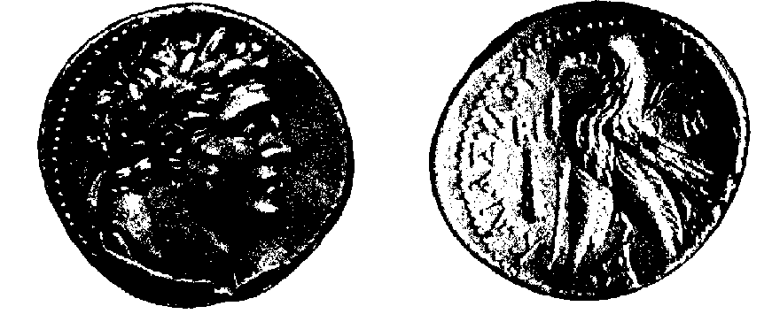

(obv: Melkart = Herakles; rev: eagle;
insc: "Tyre the Holy and Protected")
this coin accepted by Jerusalem Temple for head tax
prob stater in fish's mouth, 30 pieces silver,
coin sold by money changers

2. Roman coins
usually dated by consulate of reigning emperor
obverse usually ruling emperor
rev usually deity or personification
inscriptions fairly stereotyped, e.g.:

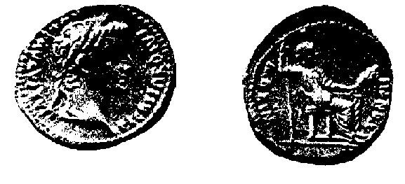

TI CAESAR DIVI AUG F AUGUSTUS / PONTIF MAXIM
Tiberius Caesar, Son of Divine Augustus, Augustus /
Pontifex Maximus (chief priest of Roman religion)
IMP CAES VESPASIAN AUG PM TRP PP COS III / IUDAIA CAPTA
Emperor Caesar Vespasian Augustus, Pontifex Maximus,
Tribunican Power, Father of the Fatherland, 3rd
Consulate / Judaea taken captive

samples:
denarius of Tiberius (obv: Tiberius; rev: Livia? Vestal Virgin?)
(above & B-28)
prob this is tribute money (see Matt 22:19)
sestertius of Vespasian (obv: Vespasian; rev: Judaea, soldier?)
(see B-35)

3. Jewish coins: no silver coins until 1st revolt (AD 66)
1st revolt coins dated, some earlier also dated
no images of people on coins
usually religious symbols or objects
variable inscriptions
samples:
large bronze of Herod (obv: tripod; rev: incense altar?
inscr: BASILEWS HERODOU, "belonging to King Herod")

prutah of Pilate (obv: augur's wand; inscr: TIBERIOU
KAICAROS, "belonging to Tiberius Caesar")
shekel of 1st revolt (68-69) (next page & B-35)
obv: cup; inscr: "shekel of Israel"; "year 3"
rev: pomegranates; inscr: "Jerusalem the Holy"
tetradrachm/shekel of Bar Kochba revolt (134-35)
obv: Jerus temple; ark? star?
rev: citron & ethrog ("bouquet" of myrtle, palm,
willow) assoc w/ Feast of Sukkoth (Tabernacles)

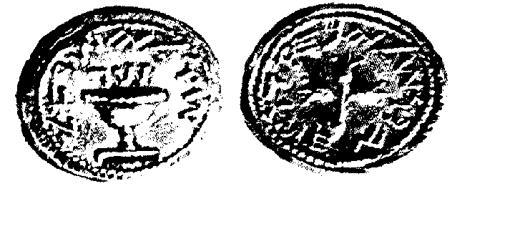

II. The Home (slide-illustrated)

A. Clothing

1. Jewish - Modern Bedouin has some resemblance to ancient rural Palestinian, as designed functionally for hot, arid climate; due to lack of Jewish pictoral art, not much information otherwise (some fabrics discovered in caves from Bar Kochba period); richer, more Hellenistic Jews followed Greek and Roman styles

2. Greek - pictorial materials from Natl Geographic, based on ancient paintings, sculpture and temple friezes
chiton, himation, peplos, chlamys, sandals

3. Roman - similar sources
tunic, toga, palla/pallium (himation)

B. Housing

1. Bedouin tent - prob similar to kind used by Abraham, etc., and by nomads, travelers at NT times (recall that Paul made tents)

2. Stone house in Palestinian village - typical flat roof w/ outside stairway, used as additional "room"

3. Standard OT period "4-room" house - rooms around courtyard

4. City houses (average city dweller) - crowded together, face inward; in Rome, walk-up apartments for poor, mansions for rich

5. Roman-style villa (wealthy rural retreats)

6. Furnishings - prob more wooden material which has not survived; rather sparse by our standards

7. Lamps - wick floating in olive oil; developed from open dish to flat pitcher by NT times

8. Pottery - much variety over centuries, between cultures; used by archeologists to date various levels of dig

C. Agriculture

1. Village Farming Culture (from BAR Biblical Archeology Slide Set)

a. Farmers' Village
lived together (gregarious, protection), fields outside village
b. Plowing - wooden plow; sometimes plowed before, sometimes after, sowing
c. Sowing - for grains, used broadcast method
d. Harvesting - by hand, with sickles
e. Winnowing grain - to separate grain from chaff after threshing, using breeze, tossing in air
f. Mortar and pestle - for grinding grain into flour
g. Grindstone & mortars - other tools for making flour
h. Baking oven - frequently outdoors, looks like pizza oven
i. Olive tree - slow growing, about 40 years to first crop, but yielded for centuries
j. Watchtower in orchard - to protect produce from theft, esp around harvest time
k. Olive press - to squeeze olive oil from olives
l. Donkey - standard animal for hauling loads
m. Loaves & fishes - pita-type bread
n. Modern (!) Palestinian vineyard - plants run along ground instead of up trellises
o. Grape leaf on coin
p. Wine decanter

2. Pastoral Culture (most from BAR set)

a. Bedouins in wilderness
b. Flocks grazing, at well
c. Woman spinning wool
d. Weaving on loom

III. Society

A. Buildings, Architecture

1. Ancient stoneworkers
2. Shrine at Machpelah (Herodian public building)
over cave where Abraham, Isaac, Jacob buried
used by archeologists for stonework in temple model
3. Greco-Roman Theatre (drama, public meetings)
often built in side of hill to save labor
4. Amphitheatre (gladitorial events)
from amphi (both sides)
Colosseum in Rome is an amphitheatre
5. Circus/Hippodrome (chariot racing)
6. Forum/Agora (Gerasa, Rome)
marketplace
7. Structures at Baalbek (Lebanon)
temples of Greco-Roman period
center for worship of Baal = Zeus = Jupiter

B. Cities

1. Typical Walled city
to protect against sudden attack

2. City houses crowded together
due to expense of militarily viable wall around city

3. Street scenes
streets narrow for same reason

4. Aqueduct
bringing water from distance, usually several miles for drinking, esp bathing

5. Roman baths
more like sauna or Turkish baths than like ours

6. Gymnasium
from gymnos - naked
exercise in various classical athletic events:
running, jumping, javelin, discus, boxing, wrestling

C. Business

1. Shops
usually downstairs of large apartment buildings or mansions, using rooms facing street

2. Potter
one of prime crafts before invention of plastic dishware

3. Weights
used in weighing merchandise and (earlier) money

4. Slave market
sold like animals, for strength, beauty, skills

D. Transportation

1. Donkey, cart
standard lightweight transport; oxen used for heavy carts
horses only for military use until invention of adequate harness in middle ages

2. Roman roads
laid straight, with cutting, bridging, curbs
excellent paving: 3-5 feet thick, using stone, concrete
narrow by our standards: four "lanes" each 7.75 feet wide

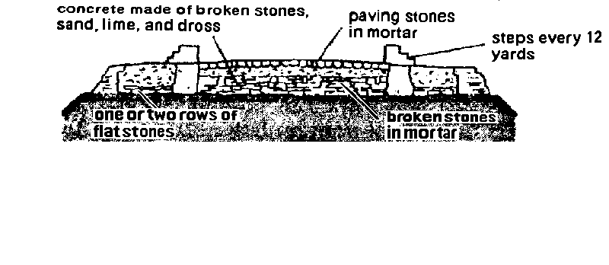

3. Roman bridge
one of important uses of arch, developed by Romans

4. Merchant ships
usually sail powered, relatively short and wide

5. Warships
powered by oars for control, long & narrow, high speed
sea battles mostly ramming and boarding
until Byzantines invented "Greek fire"

E. Religion

1. Paganism

a. Parthenon & furnishings - Athens
b. Pagan festival – sacrificial processions on festival days rather than weekly services
c. Mystery religions – usually imported from elsewhere in middle east; more individual than state religions
d. Idols – a standard feature of paganism

2. Temple at Jerusalem
a. Facade on Bar-Kochba coin, c AD 135
b. Jerusalem model
c. Menorah & incense shovel on lamp, c AD 200
d. Menorah & trumpets on Arch of Titus, c AD 80
e. Symbols of sukkoth on coin, c AD 135
citron (a citrus fruit) and lulab (bunch of fronds
from myrtle, palm, willow)
f. Libation cup, c AD 68 (drink offerings)

3. Synagogues
a. Capernaum - beautiful white limestone in area where main building material is dark basalt
b. Chorazin - up in hills a few miles N of Capernaum
c. Masada

IV. Introduction to Archaeology

A. Definition of Archaeology

1. Older definition, now obsolete:
"the study of human antiquities"
this broad definition has been subdivided into several disciplines:
history, archaeology, anthropology

2. Modern Definition (Blaiklock):
"the branch of historical research which draws its evidence from surviving material traces and remains of past human activity"

3. Humorous Definition:
"the study of durable trash"

B. Methods of Archaeology (slide illustrated)

1. The Fate of Ancient Cities

a. Fortified, usually on hills (Aleppo)
b. Frequently destroyed, but usually rebuilt if location good
c. Resultant layering (Megiddo)
d. Gradually building up a "tell" (Hippos)
e. If now unoccupied, systematic excavation feasible;
otherwise only spotty, when new building done

2. The "Dig": Archaeological Excavation

a. Trench method (Megiddo) - older technique
dig up everything in strategically located area
b. Baulk Method (Lachish) - now standard
dig squares, leaving "walls" between for stratigraphy

3. The Data Uncovered

a. Organic Remains
1) Human
2) Animal \ indications of human diet, etc.
3) Plant /

b. Artifacts: evidence of human labor
1) Pottery (NT period examples)
2) Tools & Weapons
3) Religious objects
4) Olive press
5) Mosaic
6) Coins (Masada hoard, sestertius of Vespasian)

c. Structures
1) Buildings (Qumran ruins, Capernaum synagogue)
2) Roads (Corinth: Lechaeum road; Roman road)
3) Cities
4) Fortifications (Herodium, Masada)
5) Earthworks (Masada: Roman camp)

d. Writings
1) Inscriptions: writing carved in stone
2) Ostraca: writing on potsherds
3) Documents: writing on papyrus, leather, etc.

C. Some Archaeological Sites of the N.T. Period

1. Jerusalem

a. History
pre-dates conquest by David c 1000 BC
continuously inhabited since return from Babylon c 537 BC
Jesus active here during pilgrim festivals:
trial, crucifixion, resurrection (AD 27-30)
Early apostolic activity:
Pentecost, early preaching, death of Stephen, James,
Jerusalem council, death of James the Lord's brother
destroyed by Romans AD 70
rebuilt as Roman city Aelia Capitolina AD 135
under Gentile control until 1967

b. Archaeology (Jerusalem model & modern remains)
(1) Damascus Gate
(2) Jaffa Gate & towers
(3) Fortress Antonia
(4) The Temple Mount (see picture, B-25)

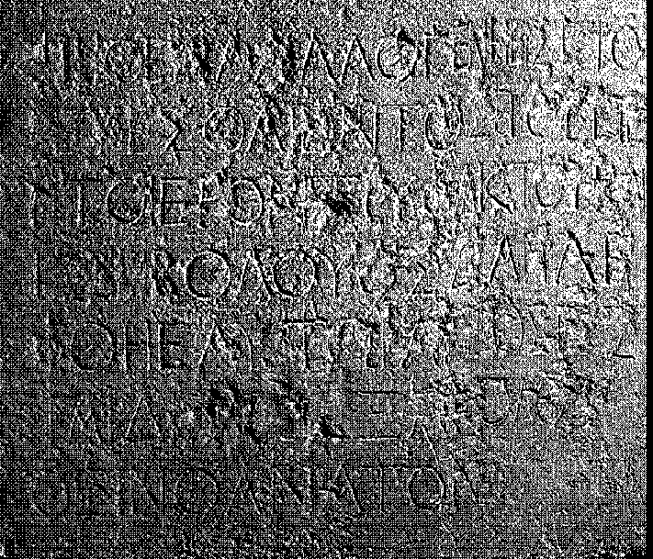

Temple Inscription: "Let no foreigner enter within the screen and enclosure surrounding the sanctuary. Whoever is taken so doing will be the cause of his own death."
2. Capernaum - Kefar Nahum (village of Nahum)

a. History
uncertain before NT times; relocated in this century;
home of Peter (Mk 1:29); synagogue mentioned (Lk 7:5)
became headquarters of Jesus during public ministry
He pronounced woes on it for not repenting (Mt 11:23)
relatively prosperous in late Roman times (3rd cen ff)
inhabited by both Jews and Xns
destroyed by Muslims 7th cen, site lost

b. Jewish Synagogue (see picture, B-27)
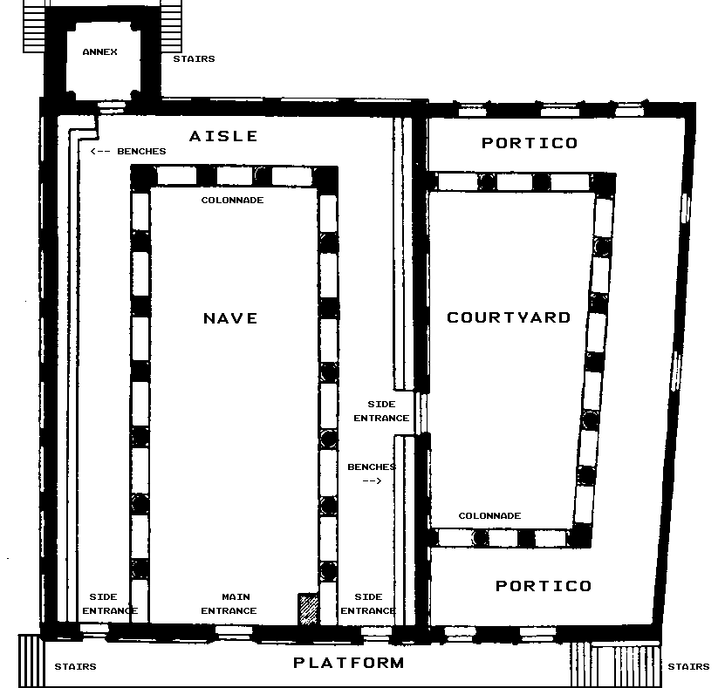

date uncertain, but prob after AD 200, on site of NT synagogue
two story bldg, c 90' x 110' (incl courtyard)
basilica-style, gable roof, white limestone
1st floor: benches for men, columns, ark-screen
2nd floor: balcony for women
carvings: menorah, ark?
pillar w/ inscription in Greek: "Herod son of Mo ... mus & Justus his son, together with his children, erected this column"
from Chorazin, for illustration: ornamental seat, prob a "Moses seat" w/ Aram inscr: "Remembered for good be Judah ben Ishmael, who made this porch & its stair-case. As his reward may he have a share w/ the righteous"

c. Christian Church
5th cen structure w/ central octagon
underneath is a 4th cen house church (which in AD 385 was said to be Peter's house)
underneath this is remains of 1st cen house with evidence it was used for worship as early as 2nd or 3rd cen

3. Caesarea (see map B-30)

a. History
prob founded by Sidonians, known as Strato's Tower, before NT times
refounded by Herod the Gt as major port c20-10 BC & named by him for Caesar Augustus
after Herod's death, made Roman capital of Palestine
Peter at Caesarea for conversion of Cornelius (Acts 10)
Herod Agrippa I died here (Acts 12)
Paul imprisoned here 2 yr, tried by governors Felix & Festus (Acts 24-26)
destroyed by Muslims c 640
rebuilt (smaller) by Crusaders c 1100, then destroyed again by Muslims c 1265
ruins now cover over 8000 acres, largest site in Palestine

b. Archaeology
most ruins from NT period, work of Herod the Great

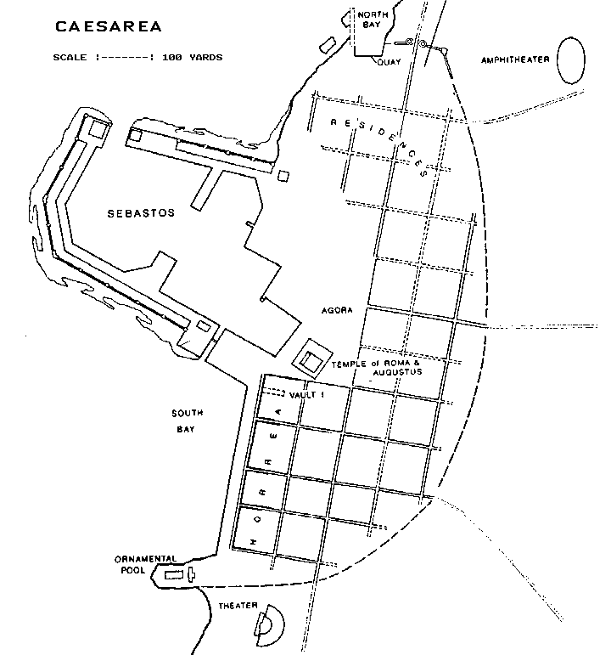

(1) Artificial Harbor
two moles (causeways) 200' wide, one 250 yd long, other 600 yd; enclose c 40 acres of water
stone blocks used up to 50'x18'x9' acc to Josephus
these have turned out to be concrete

(2) Sewer system: very extensive; designed to be cleaned by tides

(3) Aqueducts
high level: open top; 10 mi long
low level: closed; 6 mi long (later than NT period)

(4) Buildings:
Palace: perhaps on site of ornamental pool
Temple to Rome and Augustus

(5) Theatre
Pilate/Tiberius inscription (see picture, B-28)

(6) Hippodrome
~ 80 x 320 yards

4. Herodion / Herodium

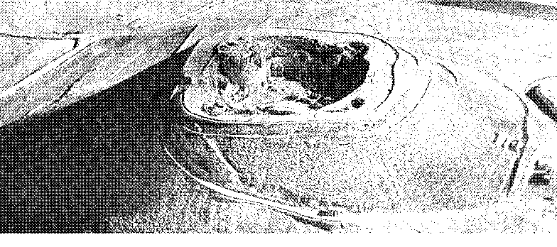

a. History
one of several fortifications built or refurbished by Herod the Great for defense, retreat
this one built from scratch 24-15 BC near Bethlehem:
natural hill artificially elevated by adding earth ramparts 150' high, giving total height 400'
top hollowed out for fortified palace, surrounded by walls & towers
after Herod's death, garrisoned by Romans
taken by Zealots in 1st revolt, retaken by Romans AD 72
major administrative center during Bar-Kochba War
since 135, only used by Christian monks in 5th-7th centuries

b. Archaeology
not excavated until 1960s
casemate (hollow) walls
four towers: 3 semicircular to defend top; 4th circular as final refuge
(poss contains Herod's gold coffin)
on top: E side: colonnaded courtyard
W side: dining room, living quarters, Roman bath
underground: storerooms, reservoirs
at foot: apartments, gardens, baths, terraces, pools, storehouses
later changes (Zealot): E sector made into synagogue, ritual bath added

c. Significance
illustrates Herod's fear of revolt (cp killing babies in Matt 2)
also illustrates Herod's lavish building activity
vivid reminder of Zealots & Bar-Kochba rebellion

5. Masada (see map, B-34)
name means "fortress, stronghold"

a. History
a natural butte / mesa / plateau / tableland
about 1300' above surface of Dead Sea
top surface fairly flat, about 1900' x 650'
app used some in times of monarchy & Maccabees, but scant remains of these periods survive
main fortification by Herod the Gt c 30 BC
built palaces, storerooms, stocked for indefinite siege
after Herod's death, garrisoned by Romans
captured by Zealots under Menachem AD 66
last holdout against Romans in 1st revolt
defended by Eleazar Ben-Yair & 960 people against Flavius Silva & 10th legion, falling in AD 73
defenders committed suicide just before capture
Roman garrison remained for ~ 50 yr
site of small Christian monastic community 5th & 6th centuries
excavated 1963-75, now national park
Israeli army motto: "Masada shall not fall again!"

b. Archaeology
no structures found before Herod's time, tho many Maccabean coins

(1) West Palace - about 190' x 190'
ceremonial use: throne room, living quarters
(2) North Palace - on three tiers at N end of mesa
private quarters of Herod, protected from sun & S-wind
well-preserved frescoes; largest Rom bath in E Rom Emp
(3) Storerooms
mostly near N end; one section c 200' x 100'
another c 100' x 100'
remains of food still survive, identifiable
wine jars with date 19 BC (consulate of Sentius Saturninus)
(4) Evidence of Zealot Occupation
oldest known example of synagogue (renovated by Zealots?) & ritual bath conforming to Talmudic reqs
many rooms in casemate walls modified with cupboards, ovens, etc.
pottery, coins, cosmetics

(5) Evidence of Roman Siege
rolling stones (c 100 lb each) near paths
Roman ballistae
destruction layer of ash & charred wood in all major buildings
frags of 14 scrolls, incl Bible (Gen, Lev, Pss, Ezk)
one apoc (Sirach), some Essene (Jubilees, Scroll of
Sabb Sacrifices)
Roman assault ramp
Roman camps (8 of them) and siege wall (2 mi long, 6' thick)

6. Corinth

a. History
one of great seaports of ancient Greece
two harbors: Cenchreae on E, Lechaeum on W
crossroads betw Aegean & Ionian Seas, betw N & So Greece
already important by 8th cen BC
destroyed by Romans 146 BC
rebuilt by Romans 44 BC
made capital of province of Achaia 27 BC
very low moral climate due to transients & Aphrodite worship (temple with 1000 prostitutes)
Paul founded church here on 2nd mj (AD 51-52; Acts 18)
spent 18 mo here; wrote 1 & 2 Cor to them; wrote Romans from here;
charged by Jews before Rom proconsul Gallio, who refused to hear case (Ac 18:12-17)

b. Archaeology
most remains from Rom period, since destroyed 146 BC
except Temple of Apollo, from 6th cen BC
Lechaeum Rd. lined with shops
Agora (forum, market place) with shops and bema where Paul presumably stood before Gallio
Inscriptions of interest:

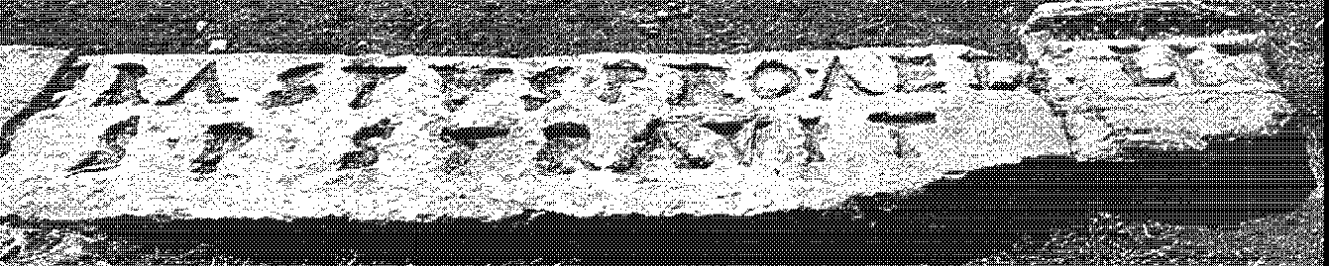

ERASTVS-PRO-AED / S-P-STRAVIT
"Erastus, in return for his aedileship, laid this pavement at his own expense" (cp Rom 16:23)
another: "Synagogue of Hebrews"

7. Rome (see map, B-24)

a. History
rose from obscurity c 500 BC to control Mediterranean by 30 BC
Pax Romana - begins with reign of Augustus, lasting over 200 yr;
general peace throughout RE; golden age of civilization,
prosperity for Rome
Paul imprisoned here 61-63 on appeal to Caesar (Nero)
Roman fire, July 64: soon blamed on Xns to divert suspicion from Nero; beginning of official persecution of Xy, lasting (off & on) to 313
Traditionally, Peter & Paul martyred here sometime in period 64-68
Christians frequently martyred here 64-313
Rome's importance continues (with ups & downs) to present
b. Archaeology
work of recovery begins in 1700s

(1) Imperial Palaces
Palatine Hill: Tiberius, Caligula, Claudius
covered by Domitian's palace
Nero's Golden House: eradicated by later emperors

(2) Roman Forum

(3) Circus Maximus: 200 x 600 yds w/ 350 yd straightaway
seated 200,000; used for chariot races, animal hunts, martyrdom of Xns

(4) Colosseum (see picture, B-36)
amphitheatre built by Vespasian & Titus (AD 80)
seated 50,000; used for gladiators, animals, Xns

(5) Mamartine Prison
traditional prison of Peter & Paul

(6) Arch of Titus
commemorating conquest of Judea

(7) Vatican
trad site of Peter's death; St. Peter's Cathedral
built over Constantinian church, which itself built over much earlier shrine

(8) St. Paul's Basilica (see picture, B-36)
about 3 mi S of Rome on Ostian Way
trad site of Paul's beheading
church from Constantine's time still standing

(9) Catacombs
subterranean cemeteries built by Xns up to 5th cen
very extensive: est over 500 mi of corridors
mainly used for cemeteries, but some use for worship & hiding during persecution, as Romans would not
violate cemeteries

"The Good Shepherd," Catacomb of Priscilla

