THE DARWIN CONVERSION STORY:
AN UPDATE

Robert C. Newman*

Abstract
Since the discussions of Rusch (1975), Rusch and Klotz (1988) and Herbert (1990), new information on the Darwin conversion story has come to light. The earliest version of the story has been located in the Watchman-Examiner, and some further biographical information on a possible candidate for Lady Hope is presented.

Introduction
Probably no other individual in modern times has had a greater influence in turning people away from the biblical account of creation, the scriptural view of mankind, and the authority of the Bible than Charles Darwin. His Origin of Species (1859) and Descent of Man (1871) were seen by many of his contemporaries as giving scientific credibility to the idea that all life developed by purely naturalistic processes. As a result Darwin provided considerable impetus for several atheistic ideologies which have dominated our troubled twentieth century.

In view of this, most people are surprised to hear that Charles Darwin allegedly became a believer in Christ near the end of his life. This story – which we should rejoice in, if true – has circulated in numerous tracts and magazine articles since 1915 (see Rusch [1975], Rusch and Klotz [1988] and Herbert [1990]). It narrates an interview with Darwin, in the fall of the last year of his life, by a "consecrated English woman" identified only as "Lady Hope." According to her account, she was allowed to visit with Darwin, and found him reading the NT epistle to the Hebrews, which he called "the Royal Book." When she asked him about Creation, he became very distressed and said that people had taken his unformed ideas and made a religion out of them. Darwin then invited her to speak to some of his servants, tenants and neighbors in his garden summerhouse on "Christ Jesus, and His salvation," and promised that he would sing along with them from his open bedroom window.

As Rusch (1975), Rusch and Klotz (1988), Herbert (1990) and others have pointed out, this account does not square well with other information we have about Darwin. His correspondence in the winter and spring following this alleged incident give no indication that Darwin's agnosticism had changed or that his belief in evolution had lessened. When Darwin's daughter Henrietta Litchfield heard this story, she denied that Lady Hope had visited Darwin, that Darwin's estate had a summerhouse, or that the "servants or villagers ever sang hymns to him." She claimed the story was invented in America (Rusch and Klotz [1988], 20-21, quoting from The Christian, 23 Feb 1922).

Some confusion exists in the various tracts as to whether this story was first reported by Lady Hope in Northfield, England or Northfield, Massachusetts. The date of her report is given as August 15, 1915. Rusch's attempt to find this report in the issues of the Watchman-Examiner available to him in the midwest was unsuccessful (Rusch and Klotz [1988], 3).

Some New Findings
Intrigued by this story and spending my summers in the Washington, DC area, I decided to try to locate the article in the Library of Congress with its extensive resources. Assuming the Watchman-Examiner was some sort of periodical and using the date of August 15, 1915 as a starting point, the search was successful. The Watchman-Examiner was a national Baptist newspaper issued weekly from Boston and New York since 1819, with some variation in name over its history. The Library of Congress has a nearly complete run of the paper. The article turned up in the first issue following the above date (Hope [1915]) and is reprinted below for your convenience:
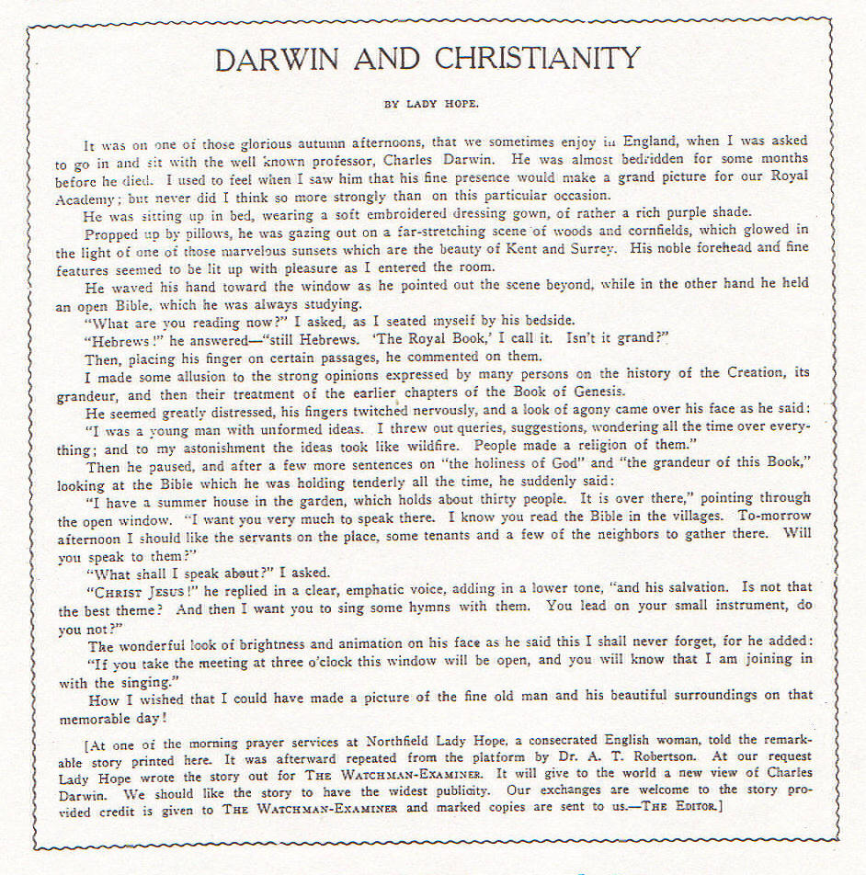

This article was preceded by a four-page report on the 1915 Northfield Conference, a summer Bible conference held on the grounds of the Northfield Seminary, a girls' school in Northfield, Massachusetts founded years before by Dwight L. Moody. The conference that year ran from July 30 to August 15, and Lady Hope gave this testimony at one of the morning prayer services, the date not specified. The particular issue of this paper was stamped as received by the Library of Congress on August 19, so the account was in print no more than a few days or weeks after she gave it orally. Thus, so far as we know, the story was first circulated in the United States some 33 years after Darwin's death. Since this is also long after Darwin's wife Emma died in 1896, the suggestion that she started the story is unfounded.

Who was this Lady Hope? The Watchman-Examiner gives us no more information than has circulated in the tracts. As reported by Rusch and Klotz (1988) and Herbert (1990), a former editor of Burke's Peerage, L. G. Pine, was asked this question also. He could come up with only one "Lady Hope" who would have been grown in 1881 and still alive in 1915, a woman he names Elizabeth Reid Stapleton-Cotton, mentioned in Burke's Peerage in the lengthy article on Viscount Combermere. In seeking to verify this reference, I discovered that Pine had mistakenly put her in the Stapleton-Cotton branch of the family, though her ancestors separated off from the line before the "Stapleton" was added. Her proper maiden name should be Elizabeth Reid Cotton.

According to Burke's Peerage and Burke's Landed Gentry, Miss Cotton was born sometime after 1841 and was married twice. Her first marriage (2 Dec 1877) was to Admiral of the Fleet Sir James Hope, G.C.B., by which marriage she became Lady Hope. He died less than four years later on 9 June 1881. So in the fall of 1881, when our story is set, Lady Hope would have been less than forty years old and recently widowed. She later married Thomas Anthony Denny (27 Sept 1893), son of a successful Irish bacon merchant and founder of T.A. Denny and Co. He, too, was much older than she (born 2 Apr 1818) and he died 25 Dec 1909. Apparently there was no issue from either marriage. Pine suggests that she preferred to be known as "Lady Hope" (certainly more prestigious than "Mrs. Denny") right up to her death (8 March 1922), but it is not known where Pine got this information. According to the 1921 edition of Burke's Peerage, her address when that edition went to press was Buccleuch House, Richmond, Surrey. Lady Hope's father, General Sir Arthur Thomas Cotton, K.C.S.I., has a brief obituary in Who Was Who, dying 25 July 1899.

Perhaps one of our British readers could follow up on this biographical information with the more extensive resources available in the U.K. It would be of considerable interest to see if this Lady Hope was the sort of Christian worker pictured in the Darwin conversion story, what Christian groups she might have been associated with, what her reputation for veracity was, and whether she visited America in 1915. Of course, Elizabeth Reid Cotton might not be the Lady Hope we are looking for.

Alternative Explanations
What can we say of the authenticity of the story itself? Besides the two suggestions that (1) Lady Hope made up the whole account, or that (2) Darwin really became a Christian but his relatives sought to cover this up, two other possibilities should be considered. (3) Perhaps Darwin did meet with Lady Hope but she later elaborated what were his much more non-committal statements. (4) Or perhaps Darwin did say all the things reported in the story, but he did so as a cover to avoid being evangelized by Lady Hope – a technique frequently encountered in personal work with unbelievers of the sort of strongly non-confrontational temperament Darwin is known to have had. The Darwin correspondence mentioned above makes alternative (2) unlikely, but there is still more work to be done before we can give a final verdict on this story.

______________

*Robert C. Newman, Ph.D., is Professor of New Testament at Biblical Theological Seminary, Hatfield, Pennsylvania, and Director of the Interdisciplinary Biblical Research Institute there.

References

________. 1908. Sir James Hope. Dictionary of National Biography 9:1212-1214. An extensive article giving his naval exploits, but only mentioning that he was married twice and had no issue. His obituary appears in the London Times, 10 June 1881.
________. 1965. Denny. Burke's Landed Gentry, 18th ed.: 200.
________. 1967. Viscount Combermere. Burke's Peerage 104th ed.: 583 (differing pagination in various editions) under Sir Arthur Thomas [Cotton], son of Henry Calveley Cotton, son of Sir Lynch Salusbury Cotton, 4th Baronet of Combermere; it was the sixth baronet who added the name "Stapleton."
Herbert, David. 1990. Darwin's Religious Views: From Creationist to Evolutionist. Hersil Publications, London, Ontario.
Hope, Lady. 1915. Darwin and Christianity. The Watchman-Examiner new series 3 (August 19): 1071.
Rusch, W. 1975. Darwin's Last Hours. Creation Research Society Quarterly 12:99-102.
Rusch, W. and J. W. Klotz. 1988. Did Charles Darwin Become a Christian? Creation Research Society Books, Norcross, Georgia.

