The Birth Pains of the Messiah:
Have They Started Yet?

Robert C. Newman
Biblical Theological Seminary
Hatfield, Pennsylvania
RCNewman@erols.com

Abstract

The concept of birth pains as a figure for eschatological troubles is investigated in the NT, OT and rabbinic literature, especially as this may relate to Jesus= comment in Matthew 24:8. Why is this figure of birth pains used? Does it have any connection with the phenomenology of birth contractions? Do we have any biblical warrant for when these troubles might begin? How do they function as signs of the end? Is there any reason from current disaster phenomena to think that the end is near?
As he sat on the Mount of Olives, the disciples came to him privately, saying, ATell us, when will these things be, and what will be the sign of your coming and of the close of the age?@ And Jesus answered them, ASee that no one leads you astray. For many will come in my name, saying, >I am the Christ,= and they will lead many astray. And you will hear of wars and rumors of wars. See that you are not alarmed, for this must take place, but the end is not yet. For nation will rise against nation, and kingdom against kingdom, and there will be famines and earthquakes in various places. All these are but the beginning of the birth pains.@
(Matthew 24:3-8, ESV).

As Jesus sat on the Mount of Olives B having left the temple for the last time before his death B his disciples asked him when his predicted destruction of the temple is to occur, and what would be the sign of his return and the close of the age. Jesus begins his response with the words quoted above. He predicts false Messiahs who will lead many astray, wars, rumors of war, famines and earthquakes. But these, he says are just the beginning of the birth pains.

What is this Abirth pains@ image? When do these pains begin? Do we have any reason to believe they may have already begun? That is what we want to look at here.

Birth Pains in the New Testament

The picture of birth pains as a figure for some severe trial is rather common in the Bible. Besides the above passage and its parallel in Mark (Mk 13:8), Paul uses a similar figure in 1 Thessalonians 5:3:

Now concerning the times and seasons, brothers, you have no need to have anything written to you. For you yourselves are fully aware that the day of the Lord will come like a thief in the night. While people are saying, AThere is peace and security,@ then sudden destruction will come upon them as labor pains come upon a pregnant woman, and they will not escape. (1 Thess 5:1-3).

Paul=s use of the figure seems to emphasize the ideas that birth pains come suddenly and are inescapable. All three of these passages seem to be eschatological.

More puzzling is a passage in Revelation 12:

And a great sign appeared in heaven: a woman, clothed with the sun, with the moon under her feet, and on her head a crown of twelve stars. She was pregnant and was crying out in birth pains and the agony of giving birth. (Rev 12:1-2).

In its context, the woman gives birth to a male child Awho is to rule all the nations with a rod of iron,@ which would clearly seem to be Jesus. If this refers to his literal birth, then the scene is set at the first coming, which is eschatological only in the sense that the whole inter-advent period, together with both comings, is eschatological. However, these birth pains might perhaps refer to Jewish recognition of Jesus as Messiah at the end of the age. Something of this sort may be in view in the first two passages of the next section.

Last of all, we have Paul=s quotation of Isaiah 54:1, in which he says the heavenly Jerusalem has no labor pains (but more children), in contrast to her rival, apparently the earthly Jerusalem.

Birth Pains in the Old Testament

Paul’s quotation reminds us that the birth pain figure has a background in the Old Testament Scriptures. In Isaiah 26, the prophet says:

Like a pregnant woman who writhes and cries out in her pangs when she is near to giving birth, so were we because of you, O LORD; we were pregnant, we writhed, but we have given birth to wind. We have accomplished no deliverance in the earth, and the inhabitants of the world have not fallen. (Isa 26:17-18).

The context here seems to be eschatological, involving resurrection (v 19) and the Lord=s coming (v 21).

Similarly, Isaiah 66:

Before she was in labor she gave birth; before the pain came upon her she delivered a son. Who has heard of such a thing? Who has seen such things? Shall a land be born in one day? Shall a nation be brought forth in one moment? For as soon as Zion was in labor she brought forth her children. (Isa 66:7-8).

The context is interesting. Verse 5 offers a contrast between those who tremble at the Lord=s word and their Abrothers@ who don=t. Verse 6 sounds like a destruction of the temple and Jerusalem. The rest of the chapter following our passage sounds eschatological.

So does Isaiah 13:

Wail, for the day of the LORD is near; as destruction from the Almighty it will come! Therefore all hands will be feeble and every human heart will melt. They will be dismayed: pangs and agony will seize them; they will be in anguish like a woman in labor. They will look aghast at one another; their faces will be aflame. Behold, the day of the LORD comes, cruel, with wrath and fierce anger, to make the land a desolation and to destroy its sinners from it. (Isa 13:6-9).

Yet this passage, for all its eschatological elements B sun, moon and stars darkened (v10), heavens and earth shaken (v 13) B seems to be a prediction of the Medes taking Babylon (vv 1, 17, 19), and so fulfilled long ago.

Psalm 48 has something of this same flavor. The kings of the earth gather against Zion, but then retreat in fear:

As soon as they saw it, they were astounded; they were in panic; they took to flight. Trembling took hold of them there, anguish as of a woman in labor. By the east wind you shattered the ships of Tarshish. (Ps 48:5-7).

Though this Zion is the city of God which he will establish forever (v 8), yet the reader is told to look over her fortifications carefully in order to tell about them to the next generation (vv 12-13). It doesn=t sound as though Zion will be standing much longer!

In Isaiah 21, the prophet is seized with pain Alike the pangs of a woman in labor@ for the coming destruction of Babylon by the Medes and the Elamites, presumably a past event by our time, yet one verse in the context (v 9, Afallen, fallen is Babylon@) is applied in Rev 18:2 to a future event.

In the prophecies of Jeremiah, the figure of birth pains is used a number of times (4:31, 6:24, 13:21, 22:23, 48:41, and 49:24) for situations in which Israel or her neighbors will be overcome at the prospect of invasion. None of these seem to be eschatological. Only Jeremiah 30 seems to look beyond the circumstances of the prophet=s time:

Thus says the LORD: We have heard a cry of panic, of terror, and no peace. Ask now, and see, can a man bear a child? Why then do I see every man with his hands on his stomach like a woman in labor? Why has every face turned pale? Alas! That day is so great there is none like it; it is a time of distress for Jacob; yet he shall be saved out of it. (Jer 30:5-7).

Besides the unprecedented nature of this event (v 7), it will result in the return of Israel from captivity, and the nation will no longer be under foreign oppressors (vv 8-9).

Thus the figure of birth pains is used for the pain and anguish of humans at terrifying circumstances that have come upon them. The idea that the circumstances are inescapable seems prominent. That the circumstances have come suddenly or unexpectedly is often possible, but less obvious.

Birth Pains of the Messiah in Rabbinic Literature

We might suppose that Jesus, in his Olivet Discourse, is doing no more than using a gripping Old Testament figure were it not for the fact that a very similar picture is used by the rabbis. The phrase Abirth pains of the Messiah@ occurs a number of times in the rabbinic literature, being cited as early as R. Eliezer (about AD 90). Since it is unlikely that the Jewish leaders (opposed as they were to Jesus) would knowingly adopt his terminology, it is probable that the phrase was already in use at Jesus= time and has been preserved to us both in the New Testament and in some of the earliest rabbinic literature which survives. The phrase as used by the rabbis does not refer to pains that the Messiah would suffer, but to Athe birth pains out of which the Messianic Age will be born.@

Some examples from the literature:

Mek Ex 16:29 (59a): R Eliezer (c90) said: If you observe the Sabbath, then you would be protected from three punishments, from the birth pains of the Messiah, from the day of Gog, and from the day of the Great Judgment.

Ket 111a: Abaye (d 338/9) stated: We have a tradition that Babel will not witness the birth pains of the Messiah.

Tanh 9a: God has shown mercy to Israel, that he led the ones with Jeconiah into the exile before the ones with Zedekiah, so that the oral Torah would not be forgotten by them and so that they would remain in Babel in their schools from that time until now. And over them has neither Edom [Rome] nor Greece had authority, not has anyone threatened them with religious persecution. And even in the days of the Messiah they will not see the birth pains of the Messiah.

Shab 118a: R Simeon b Pazzi (c280) has said, R Joshua b Levi (c250) has said in the name of Bar Qappara (c220): Whoever has three meals on the Sabbath, he becomes liable to three punishments: to the birth pains of the Messiah, to the judgment of Gehinnom, and to the War of Gog and Magog.

Pes 118a: Why do we say the Hallel [Ps 113-118 at Passover meal]? Because in it these five things are contained: the exodus from Egypt [Ps 114:1], the dividing of the Sea [Ps 114:3], the giving of the Law [Ps 114:4], the resurrection of the dead [Ps 116:9], and the birth pains of the Messiah [Ps 115:1]: ANot to us, Yahweh, not to us, but to your name give glory.@

Sanh 98b: >Ulla said, Let him [Messiah] come, but let me not see him. Rabbah said likewise: Let him come, but let me not see him. R Joseph said: Let him come, and may I be worthy of sitting in the shadow of his ass=s saddle. Abaye inquired of Rabbah: What is your reason [for not wishing to see him]? Shall we say, because of the birth pains of the Messiah?

It is clear from these passages in the rabbinic literature that the rabbis expected difficult times to come just before the Messiah appears. These times would be disastrous both for unfaithful Jews
and for the pagan nations, and even fearsome for the righteous.

When Do These Birth Pains Begin?

Jesus sketches the nature of the birth pains in the Matthew passage we quoted at the beginning of this paper: (1) false Messiahs, (2) wars and rumors of wars, (3) famines and (4) earthquakes. We should probably not take this as an exhaustive list, since the following paragraph lists additional items and is linked to our paragraph by repeated references to Athen@ and Athe end.@

Then they will deliver you up to tribulation and put you to death, and you will be hated by all nations for my name=s sake. And then many will fall away and betray one another and hate one another. And many false prophets will arise and lead many astray. And because lawlessness will be increased, the love of many will grow cold. But the one who endures to the end will be saved. And this gospel of the kingdom will be proclaimed throughout the whole world as a testimony to all nations, and then the end will come. (Matt 24:9-14)

Taking the Athen@ which opens this section to refer to the just-mentioned Abeginning of birth pains,@ we may add several more items to our list: (5) persecution, (6) apostasy, (7) betrayal, (8) false prophets, (9) increased lawlessness, (10) weakened love, but (11) worldwide gospel proclamation.

When do these things begin? Well, there have been false prophets and false Messiahs all through church history since the first century. The same is true of wars, famines, earthquakes, persecution, apostasy, and betrayal. Lawlessness and love have seen their ups and downs, but likewise wars, famines, earthquakes, and false teachers have come and gone over this whole period. Yet the gospel has gradually spread until it has nearly covered the earth. From this survey it appears that in some sense the birth pains began with the earthly ministry of Jesus.

This seems to be supported by the rather similar picture given in Revelation 6 B the opening of the seven seals. Though there is considerable disagreement about the identity of the rider on the first horse B is he Jesus, the Antichrist, or an allegorical figure for aggression? B any of these three would match one of the items above: Jesus going forth = spread of gospel (11); Antichrist = false messiahs (1); Aggression = wars (2). The identity of the other horsemen are less disputed: second horseman = wars (2); third horseman = famine (3); and fourth horseman = plague, death (either under persecution, 5, or adding another category, since war and famine usually produce death). The fifth seal is obviously death due to persecution (5), and the sixth seal is the eschatological darkening of sun and moon, and falling of stars, and a great earthquake. In fact, the response of people on earth at the time of the sixth seal closely resembles that in the passages we have looked at which compare human anguish to a woman giving birth.

So (returning to our question about when the birth pains begin), when are the seals of Revelation 6 broken? An important hint, it seems to me, is given in Revelation chapter 5:

And I saw a strong angel proclaiming with a loud voice, AWho is worthy to open the scroll and break its seals?@ And no one in heaven or on earth or under the earth was able to open the scroll or to look into it, and I began to weep loudly because no one was found worthy to open the scroll or to look into it. And one of the elders said to me, AWeep no more; behold the Lion of the tribe of Judah, the Root of David, has conquered, so that he can open the scroll and its seven seals.@ And between the throne and the four living creatures and among the elders I saw a Lamb standing as though it had been slain... (Rev 5:2-6)

Notice that the narrative suggests an interval of time during which no one is qualified to open the seals. If this is taken realistically rather than merely dramatically, then John (in his vision) is present in heaven before Jesus has completed his atoning work. But when Jesus has finished, he is now both the conquering Lion and the slain Lamb, and he is now qualified to open the seals. This suggests that Jesus is qualified to open the seals as soon as he returns to heaven from his earthly ministry. Thus, unless a long delay is assumed, it may well be that Jesus begins to open the seals immediately after his ascension. If so, then it is not surprising that the whole church age is characterized by the first five seals. It seems to me that it is not until we reach the sixth seal that we are out of the beginning of the birth pains and are approaching the end of the end.

But if the birth pains began in the first century AD, in what way do they function as signs of the end? There are a couple of alternative ways we could go here.

One way would be to say that the birth pains do not function as signs of the end in the sense that they mark the end as about to happen, but only that they function as warnings that something is wrong with mankind and with nature, and that only God can fix it, which he will do in the end. In this sense the birth pains are certainly signs of the end.

An alternative approach would be to see an additional feature implied in the picture of birth pains coming into play here. We have already noted that birth pains are painful, inescapable, and sometimes unexpected and sudden. But beyond all this, birth pains are also characterized by getting more severe and closer together as the time of birth approaches. Perhaps this would be a fruitful concept to explore.

Is there any reason to think that the features mentioned by Jesus in Matt 24:3-8 and 9-14 will get worse as the end approaches? Will there be more false Christs and false prophets B or more believable ones B who will thus deceive more people than the earlier ones did? Yes, this is supported by the narrative of the two beasts in Revelation 13 and by Paul=s description of the Man of Sin in 2 Thessalonians 2. In both passages we see nearly universal devotion given to a final false Christ. And Jesus in the Olivet Discourse emphasizes that there will be numerous false Christs and false prophets at the end (Matt 24:23-28). These passages likewise suggest more serious persecution, betrayal, apostasy, lawlessness, and weakened love as the end approaches. So too does 2 Timothy 3:

But understand this, that in the last days there will come times of difficulty. For people will be lovers of self, lovers of money, proud, arrogant, abusive, disobedient to their parents, ungrateful, unholy, heartless, unappeasable, slanderous, without self-control, brutal, not loving good, treacherous, reckless, swollen with conceit, lovers of pleasure rather than lovers of God, having the appearance of godliness, but denying its power. (2 Tim 3:1-5).

So, of the items listed in Jesus= characterization of the birth pains that precede his return, we are to expect an increasing frequency and severity of many of these. What about wars, famines, and earthquakes? The texts don=t tell us, but the sequence of seals, bowls and trumpets in Revelation is suggestive. For it is clear that the plagues of seals, bowls and trumpets become more severe as we move from an earlier sequence to a later one. And there is also reason to believe that these three sets are nested B that the seventh seal consists of the seven trumpets, and the seventh trumpet of the seven bowls. If so, this suggests that the disasters come thicker and faster as the end approaches.

So, we propose that the birth pains of the Messiah begin with the church age and run to the second coming, becoming more severe and frequent as the end approaches.

Are the Birth Pains Increasing?

This brings us to the application question. Do we see any signs today that the items mentioned in the birth pain list are currently getting worse or closer together? One reason for my examining this question occurred a few years ago. I ran across an article in the January 20, 1994 issue of USA Today that listed the ten most costly U.S. disasters up to that time:

Most Costly U. S. Disasters to January 1994
Disaster | Year | Damages (1991-94 $$)
Los Angeles quake | 1994 | >30 billion
Hurricane Andrew | 1992 | 30 billion
Midwest flooding | 1993 | 12 billion
Hurricane Hugo | 1989 | 5.9 billion
San Francisco Bay quake | 1989 | 5.9 billion
San Francisco quake | 1906 | 5.1 billion
Tropical Storm Agnes | 1972 | 4.7 billion
Southeastern drought | 1986 | 3 billion
Oakland, CA fire | 1991 | 1.5 billion
Chicago fire | 1871 | 1.5 billion

The thing that struck me at the time was that seven of these top ten disasters had happened in the past ten years! Notice that the cost of each disaster was corrected for inflation. Even allowing for the fact the U.S. is more affluent and crowded now than it was earlier, it seemed to me that these statistics still indicate an increasing level of trouble in recent years. And the USA Today list did not include the savings and loan bailout nor the AIDS epidemic. Was this crowding of disasters into recent years merely a statistical fluke? Or was God telling us something? After the terrorist attacks on the World Trade Center and Pentagon this past year, I decided to take another look at the question.

I have not been able to find any nice single compilation of the disasters listed in Jesus= catalog of birth pains, not even for the U.S. There are quite a few disaster websites. Many deal with particular disasters. Some give only the worst disasters in various categories.

I did locate a listing of ABillion Dollar U. S. Weather Disasters 1980-2001.@ This web page lists 49 items, the two most expensive being two droughts or heat waves in 1988 and 1980. If we subtract out rather diffuse Adisasters@ like these from the list, and try to compile an updated list of top ten like the earlier one in USA Today, here is what we get:

Most Costly U. S. Disasters to 2001
Disaster | Year | Damages (1998 $$)
Los Angeles quake | 1994 | >33 billion
Hurricane Andrew | 1992 | 32.4 billion
Midwest flooding | 1993 | 23.1 billion
Hurricane Hugo | 1989 | 9.9 billion
San Francisco Bay quake | 1989 | 6.4 billion
Hurricane Floyd | 1999 | 6.0 billion
Hurricane Georges | 1998 | 5.9 billion
SE severe weather/flooding | 1995 | 5.5-6.6 billion
San Francisco quake | 1906 | 5.5 billion
Hurricane Alicia | 1983 | 5.4 billion

With this updated listing, some new items come in and old ones drop off. But it is again noteworthy that six of these ten disasters occurred in these past ten years, and that nine of the ten have occurred in the past twenty years. This really suggests an increasing tempo of disaster, at least for the United States.

But here we are just looking at generic disasters (and in the U.S. at that), whereas the Olivet Discourse mentions rather specific problems (presumably world wide) in its list of birth pains. What can we make of these?

Looking back at our list on pages 4-5, we see the birth pains explicitly include:

- false messiahs
- wars and rumors of wars
- famines
- earthquakes
- persecution
- apostasy
- betrayal
- false prophets
- increased lawlessness
- weakened love
- worldwide spread of the Gospel.

This list can be condensed somewhat by combining similar categories:

- false religions of a prophetic, messianic sort (1 and 8, above)
- wars
- famines
- earthquakes
- persecution (5, 6 and 7)
- moral decay (9 and 10)
- spread of the Gospel

Let us examine each of these categories in turn.

False Religions

It is not politically correct to talk of false religions in the public sector these days. But Jesus, in speaking of false messiahs and false prophets, was addressing his followers, not the general public. We will try to use the categories we think Jesus would agree with.

There is an abundance of anecdotal testimony for the recent proliferation of false prophets and messiahs. Turning this into reliable statistics to detect a trend is another matter, however. Any database that attempts to catalog all messianic claimants, all religions, all earthquakes, all famines, etc., is faced by at least two difficulties. The first is that data is typically far more complete today (given the enormous advances in information technology) than it was even half a century ago. So we are more likely to have data for recent events than for earlier ones, whether there is any actual increase or not. The other problem is that such phenomena as we are concerned with become rarer as the phenomenon is larger. There are more small religions than large ones, more local messiahs than those with an international reputation, more minor earthquakes than major ones, more mild famines than severe ones. It is hard to detect and count the smaller events. Nevertheless, we will try to do what we can with what we have, keeping these caveats in mind.

The website www.adherents.com has data on over 4200 religious groups throughout the world, many of which we would classify as false religions of a prophetic or messianic sort. Unfortunately, the site does not provide the sort of information that could help us see whether this number is actually increasing or not.

Lacking statistics, one can make a heuristic argument. Given the increase of world population and the spread of Christian influence, there are surely more people in contact with Christianity today than earlier. Given similar percentages for positive and negative responses (see our discussion under “Spread of the Gospel,” below), there would be more people rejecting Christianity, and thus now open to various messages that combine some attractive Christian ideas with features they find preferable to the Bible’s more somber teachings. Thus it would not be unreasonable to expect some proliferation of such religions. The collapse of communist ideology in large parts of the world has opened many to currents of religious thought that were formerly kept out. The mixing of East and West, first world and third world, due to advances in communication, has also provided a local diversity that was lacking only a few decades ago. Yet the spread of technology has not banished supernatural worldviews, as the rise of the new age movement, postmodernism, and Islam attests. Even without good statistics, these factors suggest an increase in false prophets and false messiahs in the 19th and 20th centuries.

Wars

Following the pioneering work of Lewis F. Richardson in the first half of the twentieth century, a number of attempts have been made to count and categorize wars. Two helpful charts have been compiled which are relevant to our question. The first is a graph of conflicts per decade since 1400, still under construction by Peter Brecke of Georgia Tech. Although the numbers in the earlier part of this chart will certainly rise as Brecke includes information from several regions not yet compiled, he expects the dip in the 1700s to remain. The large peaks in the late 19th and 20th centuries are currently conspicuous.

Conflicts per Decade 1400-2000

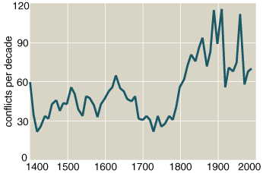

The second chart was compiled by Lewis Richardson and combines the severity of the war and its duration in a pictorial view. The severity is indicated by the war’s magnitude, given as the power of 10 of the number killed, so 3 means 10³ killed (one thousand), 6 means 10⁶ (one million), and so forth. The length of each war is indicated by a horizontal line running from the year it started to the year it ended. Richardson’s compilation runs from just after 1800 to 1950.

Wars: Severity and Duration 1800-1950

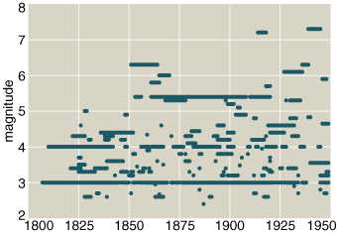

Noteworthy in Richardson’s chart is the almost unbroken chain of war somewhere in the world involving deaths of the order of one thousand to ten thousand (magnitudes 3 and 4), and the nearly continual occurrence of wars with deaths over one hundred thousand (magnitudes 5 and up) since the middle of the 1800s. Most noteworthy is the first appearance of wars with death tolls over ten million in the twentieth century.

By going back looking for major calamities of a conflict sort, Matthew White has composed a list of “(Possibly) The Fifteen Worst Things People Have Done to Each Other.” He warns us that this list is “very incomplete,” but as I have found nothing better out there, here it is:

(Possibly) The Fifteen [sic] Worst Things

People Have Done to Each Other
Death Toll | Cause
50 million | Second World War (1937-45)
40 million | Mao Zedong (1949-75)
40 million | Mongol Conquests (13th century)
25 million | Manchu Conquest (1616-44)
20 million | Taiping Rebellion (1851-64)
20 million | Annihilation of the American Indian (1492-1900)
20 million | Iosif Stalin (1924-53)
19 million | Mideast Slave Trade (650-present)
18 million | Atlantic Slave Trade (1451-1870)
17 million | Timur Lenk (1369-1405)
15 million | First World War (1914-18)
9 million | Russian Civil War (1917-22)
9 million | Thuggee (13th-19th centuries)
8 million | Fall of Rome (5th century)
7 million | Thirty Years War (1618-48)
5 million | Congo Free State (1886-1908)
5 million | Chinese Civil War (1945-49)

You may have noticed that White has slipped 17 entries into his list of 15! In any case, 6 of these occur in the 20th century, and another laps over into it from the 19th. If we remove the four multi-century atrocities from the list, half the rest occurred in the 20th century.

Famines

The major famine data I have found so far is in one of the EM-DAT databases at the Centre for Research on the Epidemiology of Disasters at the Université Catholique Louvain in Belgium. Though nominally this famine database covers 1900-2000, in fact it is incomplete, and as yet lists no famines before 1931. The two graphs below group the famines in ten-year periods and present them as bar graphs, the first including all famines in the database for the period, the second just famines affecting more than one million people.

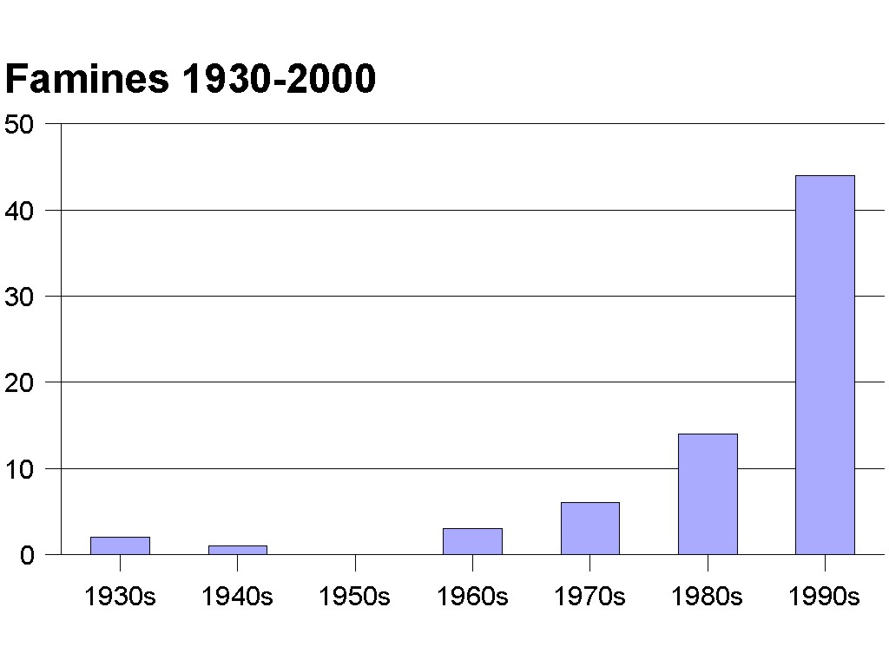

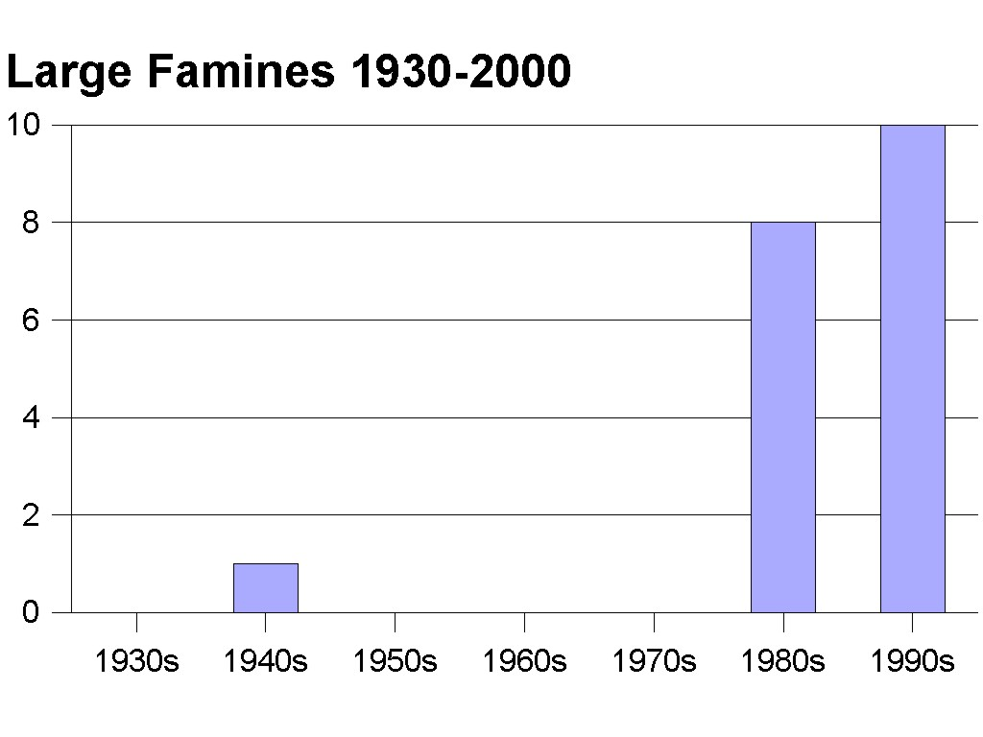

There certainly appears to be an increase in famines here.

Earthquakes

The National Earthquake Information Center of the U.S. Geological Survey has two lists of earthquakes which have occurred since 1900, one listing earthquakes resulting in more than one thousand deaths, the other earthquakes of magnitude 7.0 or larger. The earthquakes in this latter tabulation should be large enough that none have been missed over that time period.

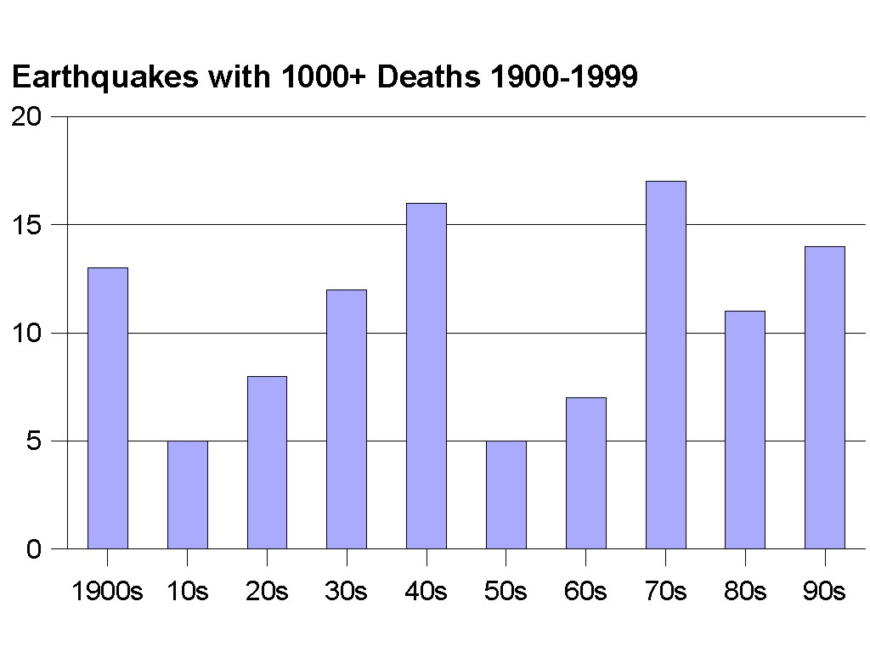

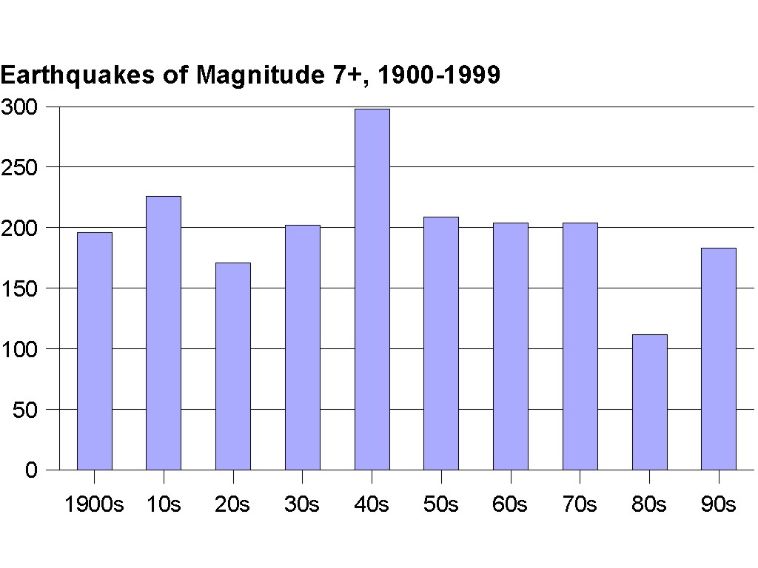

There does not seem to be any increase in earthquake number or severity over this period.

Persecution

The second edition of the World Christian Encyclopedia provides a summary entitled “The phenomenon of martyrdom.” The total number of martyrs for the Christian faith is estimated at 69.42 million from the beginning of Christianity to A.D. 2000. No statistics are given to divide up this total by centuries except to indicate that the number of martyrs in the 20th century was 45.4 million, of which 13.3 million of these have died since 1950. Further, the summary indicates the average annual rate of martyrdom since 1950 as 278 thousand, with the current rate about 160 thousand. Thus we see a very large jump in martyrs in the 20th century, amounting to over 65% of the total since the time of Christ.

Within the 20th century, over two-thirds of the martyrs died before 1950, with lower rates since then. Still, the average rate of martyrdom over the 19.6 centuries since the beginning works out to 3.5 million per century (or for the 18.6 centuries up to 1900 as 0.75 million), while the average for the whole 20th century is 45.4 million, over ten times larger, and the average currently is 16 million per century, still over four times the twenty-century average.

Moral Decay

Probably crime statistics are the most objective way to measure this feature. Unfortunately, the collection of worldwide crime statistics is still in its infancy. The U.N. Office for Drug Control and Crime Prevention has now conducted five crime and justice surveys, in 1974, 1978, 1984, 1988, and 1994. These results are reported in the 1999 Global Report on Crime and Justice. The summary of chapter two notes that, “On average, crime continued to rise in the 1990s, as it had in the 1980s.” This is qualified by the note, “Many countries showed a fall in crime in the 1990s.” The following two charts indicate some of these changes. In the first, the median rate of intentional homicide for each of the five surveys is given, the number being the rate per 100 thousand population. The developing and industrial nations are compared.

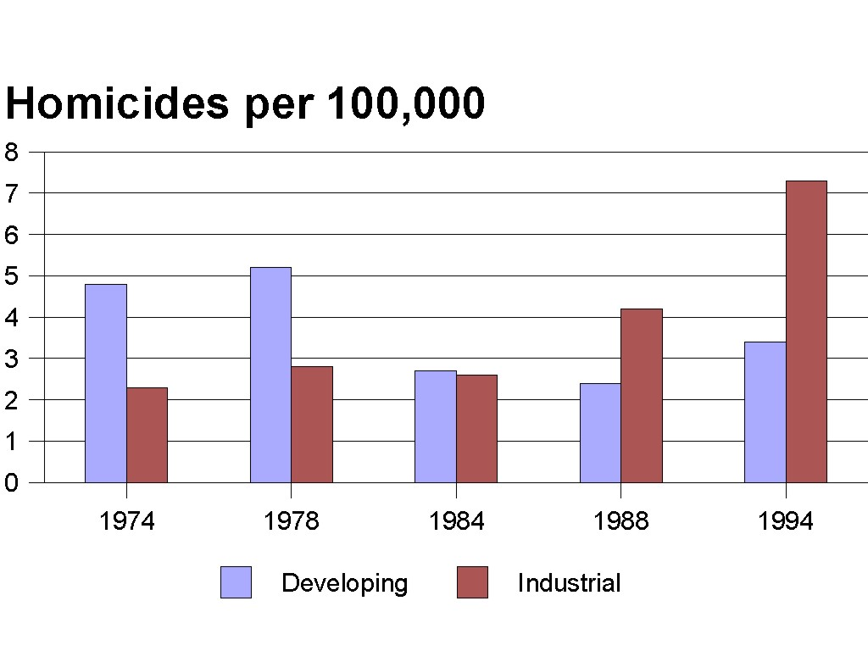

The second chart gives the number of countries reporting an increase or decrease in the rate of homicide, rape and theft between the 1986 survey and the 1994 survey.

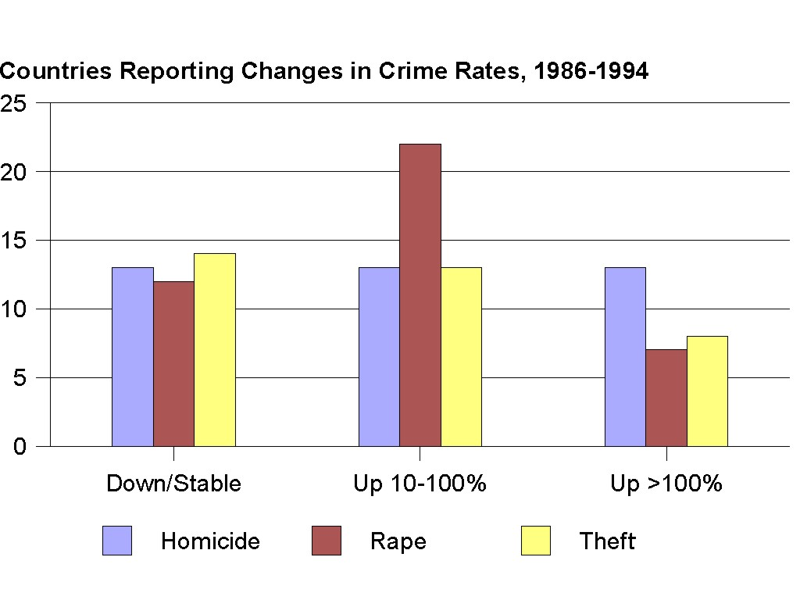

From this latter chart it is clear why the report indicates that serious crime is up in the 1990s.

Spread of the Gospel

It is clear from the Bible that only a minority of people will be saved by God’s free offer of salvation, though many would argue that this will become a majority when children dying in infancy are taken into account. In any case, Jesus predicts “this gospel of the kingdom will be proclaimed throughout the whole world as a testimony to all nations, and then the end will come” (Matt 24:14). Though we are probably not to understand this as a “birth pain,” the completion of this task might very well be seen as a sign of the end. Where do things stand in this regard?

The second edition of the World Christian Encyclopedia provides a large spreadsheet listing numbers of adherents to the various world religions for 1900, 1970, 1990, 2000, and then provides extrapolations to 2025 and 2050. In the chart below, we extract the percentages of unevangelized persons, evangelized non-Christians, and Christians for the four dates which are now past. By “evangelized non-Christians,” the authors mean those who have heard the Gospel but have not accepted it.

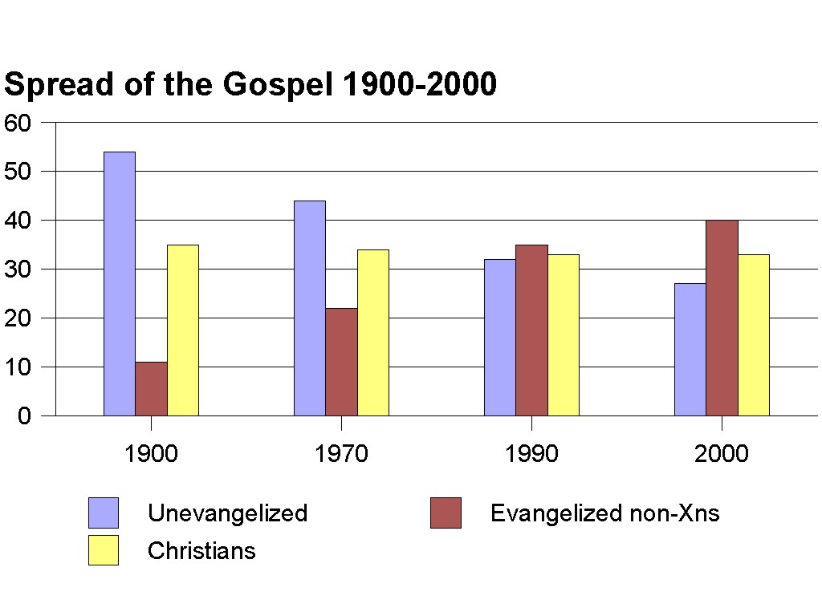

It is clear that the twentieth century has decreased the fraction of people to whom the Gospel has never been proclaimed from over 50% to under 30%, even though the fraction of the world population that professes Christianity has remained about the same (actually decreasing slightly from 34.5% to 33.0%).

As a matter of fact, the Gospel is already available everywhere in the world via radio in the major languages of the world. Only a small percentage cannot hear it proclaimed in some language they understand, though it may not be easy to assimilate due to cultural barriers of various sorts.

Discussion and Conclusions

We have now looked at seven items (condensed from a larger list) that might be considered the birth pains of the Messiah in Matthew chapter 24. We suggest that these features characterize the period between the ascension and second coming of Jesus. They certainly function as signs of the end in the sense that they show us the need for God’s intervention to rescue us from sin and its effects. We also suggest there is good warrant from Scripture for expecting these features to become more severe and more frequent as the end arrives.

To the question whether these items are currently increasing in frequency or severity we have found a mixed answer. Probably the number of false religions of a prophetic and messianic sort is increasing (and the number of their adherents), but as yet I have not found definite statistics to prove this. Wars have increased in severity if not in frequency in the past two centuries, though as I write no major international war is in progress. Famines seem clearly to have increased in recent decades. Earthquakes have not. Persecution of Christians has certainly been unprecedented in severity during the past century. Moral decay, as measured by crime statistics, has risen significantly in recent decades. The Gospel has been spread in this past century to the extent that the fraction of people who have been exposed to the message has risen from about 44% in 1900 to about 73% in 2000.

One could make a case that - beyond being in the end-times in the sense that these began with Jesus’ ascension - we are in the early stages of events leading up to Jesus’ return. There is still nearly 30% of the world’s population that has not been exposed to the Gospel, but this could change rapidly with advancing technology. There is still no sign of an increase in earthquakes despite frequent claims to the contrary, but this could also change quickly. We must, as Jesus said, continue to watch and pray.

References

. Hermann L. Strack and Paul Billerbeck, Kommentar zum Neuen Testament aus Talmud und Midrasch (Munich: C. H. Beck, 1922), 1:950, my translation.
. Compiled from Strack and Billerbeck, 1:950 Where the source was easily available, I have used a standard English translation. Otherwise, these are my own translations from the German.
. I am inclined (with numerous commentators) to see the seventh seal as including the seven trumpets, and the seventh trumpet as including the seven bowls. Thus the sixth seal may be right on the threshold of the end.
. This is in agreement with the view of Anthony A. Hoekema, The Bible and the Future (Grand Rapids: Eerdmans, 1979), pp. 136, 150, 153, 157-8.
5. USA Today, 20 January 1994.
. See Thomas S. Parris, ADisasters On-Line,@ Environment 42, no. 4 (May 2000), reprinted on-line at www.environment.harvard.edu.
. Located on the website www.ncdc.noaa.gov.
8. e.g., Ronald Enroth, The Lure of the Cults & New Religions (Downers Grove, IL: InterVarsity, 1987), pp. 41-42, 45, 53, 56, 110, 123.
. The site features a number of items, including an index of religions by name, and a listing of the major religions of the world ranked by number of adherents, plus some links to other sites.
10. Lewis F. Richardson, Statistics of Deadly Quarrels, Quincy Wright and C. C. Lienau, eds. (Pittsburgh: Boxwood Press, 1960); Arms and Insecurity: A Mathematical Study of the Causes and Origins of War, Nicolas Rashevsky and Ernesto Trucco, eds. (Pittsburgh: Boxwood Press, 1960).
11. See the bibliographies in Brian Hayes, “Statistics of Deadly Quarrels,” American Scientist 90 (Jan-Feb 2002): 10-15; Matthew White, “Source List and Detailed Death Tolls for the Man-made Megadeaths of the Twentieth Century,” http://users.erols.com/mwhite28/warstats.htm; Peter Brecke, “Violent Conflicts 1400 A.D. to the Present in Different Regions of the World,” http://www.inta.gatech.edu/peter/PSS99_paper.html.
12. Figure 6 in Hayes, “Statistics of Deadly Quarrels,” p. 15; see also Brecke’s website at http://www.inta.gatech.edu/peter.
13. Figure 4 in Hayes, “Statistics of Deadly Quarrels,” p. 13
14. Matthew White, “Selected Death Tolls for Wars, Massacres and Atrocities Before the 20th Century,” http://users.erols.com/mwhite28/warstat0.htm.
15. The CRED has databases for natural disasters from 1900-2001, technological disasters for the same period, conflicts from 1991-2000, as well as for famines from 1931-2000. See their website at http://www.cred.be/emdat/intro.html.
16.“Earthquakes with 1,000 of More Deaths from 1900,” http://neic.usgs.gov/neis/eqlists/eqsmajr.html.
17. “Number of Earthquakes per Year Magnitude 7.0 or Greater, 1900-1999,” http://neic.usgs.gov/neis/eqlists/7up.html.
18. This is in agreement with the assessment by the USGS. See http://neic.usgs.gov/neis/general/handouts/increase_in_earthquakes.html.
19. David B. Barrett, George T. Kurian, and Todd M. Johnson, eds., The World Christian Encyclopedia, 2nd ed., 2 vols. (Oxford: University Press, 2001), 1:11.
20. Graeme Newman, ed., Global Report on Crime and Justice (New York: Oxford University Press, 1999). Excerpts are available on the web at http://www.uncjin.org/Special/GlobalReport.html.
21. Chapter 2 summary at http://www.uncjin.org/Special/c2.html
22. Global Report on Crime and Justice, p. 50.
23. Global Report on Crime and Justice, p. 52.
. World Christian Encyclopedia, 1:4.

